CALIFORNIA STATE UNIVERSITY SACRAMENTO

COLLEGE OF ENGINEERING AND COMPUTER SCIENCE

*Authors:*

Andrew Hall

Andersen Huey

Justin Lieu

Kelly Lopez

Fethi Belkouche, Suresh Vadhva, Douglas Thomas

**Semi-Autonomous Gas Analysis Tool**

December 18th, 2020



**TABLE OF CONTENTS**

**Executive Summaryv**

**Abstract1**

**Index Terms1**

1. **Introduction1**
2. **Societal Problem2**
3. Evidence of Climate Change2
4. Spring Societal Problem Focus3
5. Fall Societal Problem Focus5
6. **Design Idea6**
7. Spring Design Idea6
8. Hardware6
9. Software10
10. Fall Design Idea10
11. Hardware10
12. Software12
13. **Funding13**
14. **Project Milestones13**
15. **Work Breakdown Structure**1**4**
16. Work Breakdown14
17. Scheduling14
18. **Risk Assessment15**
19. **Integration Plan15**
20. **Conclusion16**

**References16**

**Glossary19**

**Appendix A. User ManualA-1**

**Appendix B. HardwareB-1**

**Appendix C. SoftwareC-1**

**Appendix D. MechanicalD-1**

**Appendix E. Work Breakdown StructureE-1**

**Appendix F. ResumeE-1**

**TABLE OF FIGURES**

Fig. 1. CO2 Atmospheric Levels [1]2

Fig. 2. Greenhouse Gas Emissions in 2018 [3]2

Fig. 3. 2100 Predicted Sea Level Change [5]3

Fig. 4. 1971-2000 v 2041-2070 Fire Risk [9]3

Fig. 5. Estimated Acre Damage With and Without Climate Change [12]4

Fig. 6. 2003-2007 Emissions Compared to 2018 Daily Emissions [14]4

Fig. 7. Number of Properties at High to Extreme Risk from Wildfires [16]5

Fig. 8. Billion-dollar events to affect the US from 1980-2020 [17]5

Fig. 9. Cause of Pipeline Leaks: 2010-2019 [19]5

Fig. 10. Estimated Gas Leak at Aliso Canyon [21]6

Fig. 11. Raspberry Pi 4 Model B [24]7

Fig. 12. Arduino Nano [25]7

Fig. 13. DHT11 Temperature-Humidity Sensor [26]7

Fig. 14. MQ2 Combustible Gas and Smoke Sensor [27]7

Fig. 15. MQ-7 Carbon Monoxide Sensor [28]8

Fig. 16. OV5647 Camera [29]8

Fig. 17. SG90 Servo [30]8

Fig. 18. Tank Chassis [31]8

Fig. 19. 9 Volts DC Motors [31]9

Fig. 20. L298N H-Bridge [32] 9

Fig. 21. 18650 Rechargeable Lithium Ion Battery [33]9

Fig. 22. RAVPower Portable Power Bank [34]9

Fig. 23. SteelSeries Stratus XL Bluetooth Controller [35]9

Fig. 24. Design GUI [36]10

Fig. 25. DHT22 Temperature and Humidity Sensor [37]11

Fig. 26. ME2-O2 Oxygen Sensor [38]11

Fig. 27. MQ135 Air Quality Sensor [39]11

Fig. 28. SIM868 GPS Module [40]11

Fig. 29. Rover Interior [36]12

Fig. 30. Rover with Enclosure [36]12

Fig. 31. Updated GUI for Fall 2020 [36]12

Fig. 32. Risk Matrix [36]15

Fig. B-1. Spring 2020 Hardware Schematic [36]B-1

Fig. B-2. Fall 2020 Hardware Schematic [36]B-2

Fig. B-3. Spring 2020 Hardware Block Diagram [36]B-3

Fig. B-4. Fall 2020 Hardware Block Diagram [36]B-4

Fig. B-5 MATLAB Carbon Monoxide Plot [36]B-5

Fig. B-6 MATLAB LPG Plot [36]B-6

Fig. B-7. MATLAB Temperature Plot [36]B-7

Fig. B-8. MATLAB Humidity Plot [36]B-8

Fig. B-9 MATLAB Carbon Dioxide Plot [36]B-9

Fig. B-10 MATLAB Oxygen Plot [36]B-10

Fig. C-1. Web Server/GUI Flow Chart [36]C-1

Fig. C-2. Rover Movement and Controls Flow Chart [36]C-2

Fig. C-3 Code Snippet for Accepting Input From the GUI and Updating Resolution/Frame Rate [36]C-3

Fig. C-4. Code Snippet for Updating GUI Sensor Data and Writing to CSV file [36] C-3

Fig. C-5. Code Snippet for Controlling the Rover via Keyboard [36]C-4

Fig. C-6. Code Snippet to Read the LPG and CO Values from the MQ2 [36]C-5

Fig. C-7. Code Snippet To Read Oxygen Percentage from the ME2-O2 Oxygen Sensor [36]C-5

Fig. C-8. Code Snippet to Send Sensor Data to Raspberry Pi via USB [36]C-5

Fig. D-1. Tank Chassis [31]D-1

Fig. D-2. Rover with Enclosure [36]D-2

Fig. E-1. Fall 2020 Work Breakdown Structure [36]E-1

Fig. E-2. Spring 2020 Work Breakdown Structure Diagram [36]E-2

Fig. E-3. Fall 2020 Work Breakdown Structure Diagram [36]E-2

**TABLE OF TABLES**

Table 1. Component Costs [36]13

Table 2. Spring 2020 Milestones [36]13

Table 3. Fall 2020 Milestones [36]14

Table D-1. Mechanical Specifications [36]D-1

EXECUTIVE SUMMARY

Gas leaks are an unpredictable and inevitable threat that can endanger lives and infrastructure. While there are devices and procedures currently in place to combat leaks, our team has designed a semi-autonomous robot to provide an additional option to response personnel. The robot will provide users the capability to remotely identify leaks without putting themselves at risk. This report encompasses details involving work, research, and personal experiences while developing this project over the Spring 2020 to Fall 2020 school year.

The first portion of this report will cover the societal problem that our project aims to help resolve and the changes to our focus after feedback and deliberate thought. As such, figures, statistics, and scientific evidence will be provided to justify the need to address the societal problem. This will be conjointly related to the formulation of our design idea and the multiple iterations we have undergone because of feedback, time constraints, and reassessments. Additionally, this will include how we realized the requirements of our design in relation to the problem, measurable metrics, division of tasks based on individual experience, and funding.

The second portion of this report will cover project milestones and the work breakdown structure that will detail the different components of our design as well as the responsibilities of each team member. Moreover, all projects have some level of risk assessment must be performed to account for unexpected delays, accidents, and similar extraneous events. A plan is imperative to quickly responding to these events to mitigate and reduce any disruptions that may inhibit the delivery of the project. One major obstruction that we faced was global pandemic caused by COVID-19 that severely affected the development and roll out of our project. Thus, a plan involving social distancing was implemented to ensure the health and safety of each individual while still allowing work to proceed.

The last portion of this report will cover technical documentation on the operation of our project at both a high and low level. In terms of high level, a detailed manual will be provided to instruct inform users on the operation of the device. Flowcharts and block diagrams will provide insight on the workings of hardware and software components. As for low level, detailed documentation about code, hardware, mechanical components will elaborate on the underlying workings of the device. Furthermore, documentation regarding software and hardware testing procedures will help provide confidence in the validity and functionality of our project.

Overall, this report is a comprehensive document that summarizes past assignments and provides a step by step overview on our approach to resolving our societal issue. Hardware and software documentation will provide insight on the functionality of our design and serve as verification that our device can compete with preexisting solutions.

Semi-Autonomous Gas Analysis Tool

Andrew Hall, Andersen Huey, Justin Lieu, Kelly Lopez

Department of Electrical & Electronic Engineering, Computer Engineering Program, CSU Sacramento

6000 J Street, Sacramento, CA, USA

***Abstract –* Climate change is a global phenomenon that stems from a wide variety of both natural and anthropogenic causes. While there are a multitude of man-made sources of climate change, gas leaks involving hydrocarbons are an exceptional contributor. To help alleviate the impact of gas leaks on climate change our team has designed the Semi-Autonomous Gas Analysis Tool which will allow personnel the ability to remotely identify leaks. For all intents and purposes, this device will allow users to quickly identify leaks to minimize the impact on climate change, surrounding infrastructure, and health while simultaneously ensuring the safety of the operator. This report will summarize the work and research that our team has conducted from the Spring 2020 to Fall 2020 school semesters. The contents of the report can be divided into three parts where the first part contains our societal problem and our process of realizing our design to resolve the societal problem. The second portion will contain information about project milestones, the work breakdown structure, risk assessment, and both the current and future state of our design. The last section will contain information about risk assessment, issues faced during development, and both the current and future state of our design. This report will cover the process of conceptualizing our design to its deliverable prototype phase.**

***Index Terms –* Robotics, Gas Analysis, Gas Leak, LPG, CO, CO2, ppm, Remote Control, Data Collection, Semi-Autonomous**

1. INTRODUCTION

The purpose of this documentation is to summarize the work and research that our team has conducted for the Spring 2020 to Fall 2020 school semesters. The project was completed in accordance with the requirements and guidelines of California State University’s (CSUS) College of Engineering & Computer Science’s senior design course.

Regarding the subject matter, the team was tasked with identifying a societal problem and designing a piece of technology to resolve it in some capacity. Thus, we chose to address gas leaks and their impact on climate change by developing the Semi-Autonomous Gas Analysis Tool. Equipped with a multitude of sensors and features such as a graphical user interface (GUI) and global positioning system (GPS), the device will allow personnel to remotely identify gas leaks in an industrial or commercial setting. Doing so will ensure the safety of the user while simultaneously identifying the leak in the shortest time possible so that potential infrastructure damage, business disruptions, and contributions to climate change can be avoided.

In the context of the report, it can be divided into three separate sections. Beginning with the first, it will cover facts and statistics about climate change and some of the major contributors to this global phenomenon. Additionally, this will tie in with how we determined our design idea and the multiple iterations that we have cycled through because of feedback and evaluations. The second section will involve project milestones and the work breakdown structure that will reveal how we tracked our progress as well as the more fundamental systems of our design. The second section will also include the risk assessment that we have conducted and how our team adapted because of COVID-19 restrictions. Lastly, the third section will contain technical documentation such as the user manual, block diagrams, flowcharts, and detailed information about our code and components.

1. SOCIETAL PROBLEM

Climate change is a natural phenomenon that has occurred many times throughout Earth’s history. However, recent studies have observed an exponential rise in global temperatures that are attributed to anthropogenic causes. While the effects of climate change are not immediately noticeable, the current rate of progression is unsustainable and may cause irreversible damage in the future. Thus, it is imperative that we address human contributions to climate change and develop some technology to counteract it.

1. *Evidence of Climate Change*

Climate change refers to long term and global variances to pre-established weather patterns such as rainfall, temperature, and wind patterns. Unlike most causes and effects, climate change is a gradual event that remains unnoticed until significant harm to human health and the environment have occurred. Although there is no firsthand evidence of past climate change, ice core samples taken from ice sheets and glaciers reveal compelling evidence. By measuring the carbon dioxide (CO2) density at different heights of the ice cores, scientist can estimate the average temperature of Earth dating back hundreds of thousands of years.

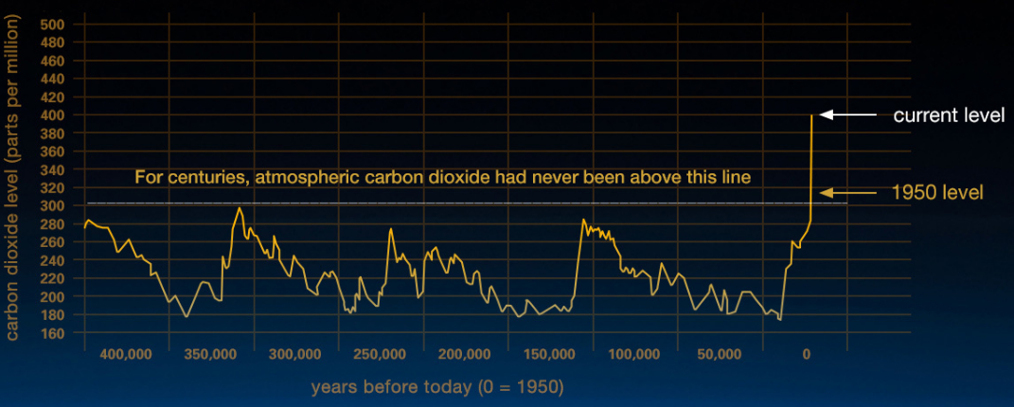

Fig. 1. CO2 Atmospheric levels [1]

Through past carbon dioxide atmospheric level measurements and current measurable levels, the scenario that we face is an unprecedented global rise in temperature. Also known as global warming, this phenomenon “refers to the rise in global temperatures due mainly to the increasing concentrations of greenhouse gases in the atmosphere” [2]. Of the many greenhouse gases present in the atmosphere, three of the top contributors stemming from human related emissions are water vapor, carbon dioxide, and methane (CH4).

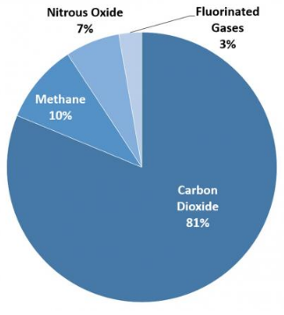

Fig. 2. Greenhouse Gas Emissions in 2018 [3]

These emissions are predominantly byproducts from human activity involving the production, transportation, and consumption of goods and services. In the case of carbon dioxide, the combustion of fossil fuels and organic matter such as waste and wood contribute a great deal to emissions as seen on figure 2. As for methane and nitrous oxide (N2O), they share some relation to the combustion of fossil fuels, but they are also related to agricultural practices [3]. Although these practices are essential for day to day operations, the lack of strict regulation is a huge liability that is accelerating climate change which will have dire consequences.

In terms of consequences there are a wide variety that are currently impacting us, and more are projected to affect us. One significant threat is the rise of global sea levels that is currently estimated to be rising at a “rate of one-eighth of an inch per year” [4]. Despite this miniscule increase, the numbers add up and within the next 50 years we can expect the global sea levels of at least 6.25 inches if not more.

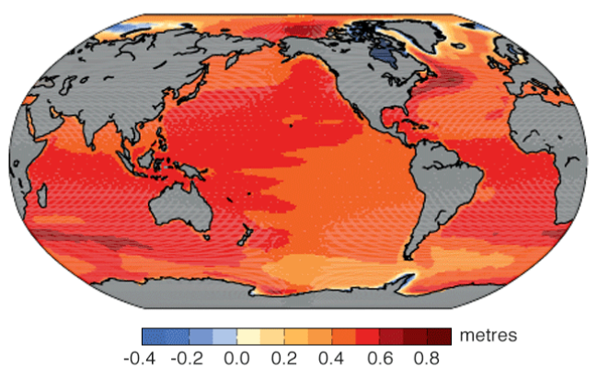

Fig. 3. 2100 Predicted Sea Level Change [5]

This rise can further erosion and increase the severity of natural disasters such as floods, tsunamis, and hurricanes. Moreover, costal cities and regions can expect to be underwater if rising sea levels are not halted. Another threat of global warming are the adverse effects on the environment and ecosystems. For instance, rising temperatures can disrupt delicate biological functions of animals such as sea turtles. According to a survey performed on Raine Island, Australia, home to the largest green sea turtle nesting ground within the Pacific Ocean, “Sand temperatures there had increased so much, … that female baby turtles now outnumber males 116 to 1” [6]. Similarly, warmer temperatures have caused flora namely algae to have extreme growth in what is known as algal blooms. These blooms can pose as a serious hazard to humans and wildlife because of the toxins produced by a select number of species [7]. Hence, climate change is a societal issue that must be addressed to prevent further damage and preserve our future.

1. *Spring Societal Problem Focus*

Given the complexity and the scope of climate change, our team decided to narrow down the societal problem and focus on the effects of wildfires in relation to climate change for the Spring 2020 semester. Providing a preface, wildfires are an essential part of nature that provide a mechanism for renewal and growth, but rising temperatures and human suppression has exacerbated these events [8]. While years of human fire suppression is partly to blame for increasing wildfire intensity, our main intention is to examine the role of wildfires on climate change and vice versa.

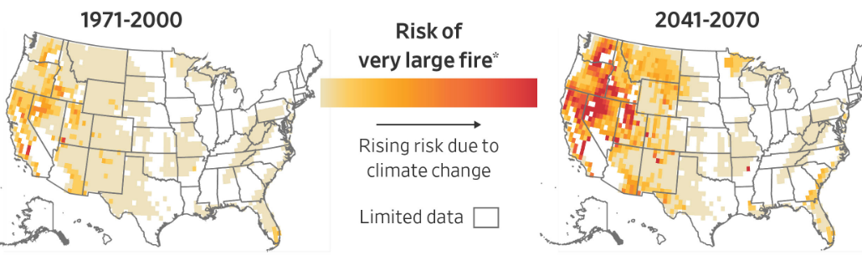

Fig. 4. 1971-2000 v 2041-2070 Fire Risk [9]

Regarding climate change’s role on wildfires, higher temperatures result in dryer conditions that are ideal for fires. According to Christine Lee, Master of Environmental Management, “there is a general consensus that climate change is and will be a primary driver of trends in wildland fires, outweighing even direct human influence on wildland fire patterns” [10]. In other words, the role of increase temperatures is far more of a concern than human suppression of wildland fires; thus, reaffirming our goal of addressing climate change. In terms of numerical data, projections indicate that “Artic mean summer temperature is predicted to increase 2- 9°C by the end of the century, and the forest fire frequency is expected to at least double per 1°C rise in temperature” [11]. Referring to Figure 4, this image shows the comparison between past and predicted fire risks that align with the correlation of temperature and wildfire frequency. This data evidently shows that rising temperatures has serious ramifications that will only aid in the acceleration of climate change and increase health and infrastructure damage.

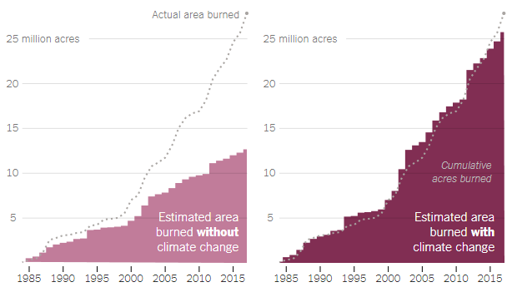

Fig. 5. Estimated Acre Damage With and Without Climate Change [12]

Considering the byproducts and general concerns of fires, the contributions of wildfires to climate change, health, and infrastructure are evident. Speaking of the byproducts the main derivative of wildfires is carbon dioxide that is released in large amounts because of the combustion of plant matter. As reported by the US Department of Interior, “the 2018 wildfire season in California is estimated to have released emissions equivalent to roughly 68 million tons of carbon dioxide… about 15 percent of all California emissions” [13]. Referring to figure 2, the 68 million tons of carbon dioxide released in California’s 2018 wildfire season represents a substantial number of the US’s reported 81% carbon dioxide emissions. These numbers are baffling and demonstrates how carbon dioxide remains as one of the top greenhouse gases that are empowering climate change.

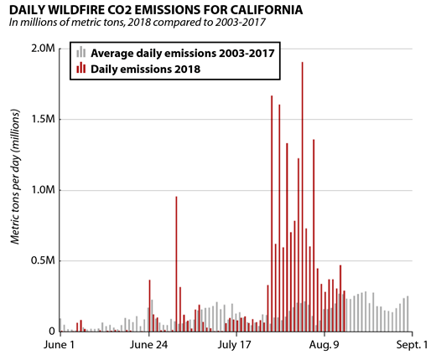

Fig. 6. 2003-2007 Daily Emissions Compared to 2018 Daily Emissions [14]

Examining health and infrastructure concerns of wildfires, they can easily cause life threatening health issues and billions of dollars in damages. For health, carbon dioxide, ash, and other pollutants can severely affect air quality for hundreds of miles given ideal wind conditions. Per Dr. Reisen, expert in Environmental Toxicology, “Particle size, shape and composition are important factors to consider for health effects… ultrafine particles (diameters smaller than 0.1 µm) are also able to penetrate the lung lining and enter the blood” [15]. Elaborating on this, children, elderly, and sensitive individuals would easily be susceptible to poor air quality caused by wildfires. If precautions are not taken, it would be very like for them to face respiratory and heart problems that may prove to be fatal. As for monetary damages, wildfires destroy a significant number of properties that impact families and businesses.

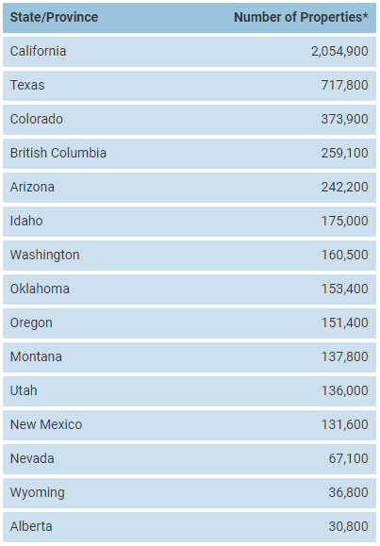

Fig. 7. Number of Properties at High to Extreme Risk from Wildfires [16]

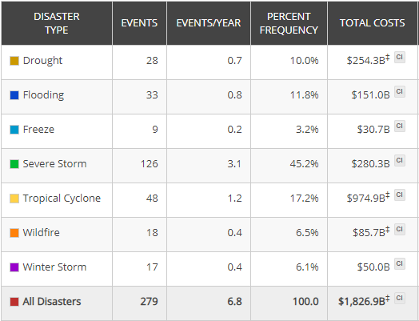

Fig. 8. Billion-dollar events to affect the US from 1980-2020 [17]

Shown through figure 7 and figure 8, California has just over 2 million properties at risk from wildfires with a national cost of 85.7 billion dollars in damages. Considering the present-day and potential harm of wildfires, our team chose to resolve some aspect of wildfires to combat its consequences to both climate change, health, and infrastructure.

1. *Fall Societal Problem Focus*

After receiving feedback from advisors and professionals on our design idea, our team has decided to revise our societal problem focus from wildfires to gas leaks. Unlike wildfires that occur naturally, gas leaks are an inevitable threat stemming directly from the production, transportation, and consumption of natural gases. Stated by the US Department of Energy, “natural gas consumption in the US is expected to increase 50% within the next 20 years… ensuring natural gas infrastructure reliability is one of the critical needs for the energy sector” [18]. With the growing reliance on natural gases there is a proportional increase to the risk of gas leaks occurring. Although maintenance and technology can prevent them to some degree, corrosion and high pressures within the pipes will gradually lower the structural integrity of couplings and the pipe itself. Shown in figure 9, most pipeline leaks can be attributed to equipment failure and corrosion because of exposure to the elements.

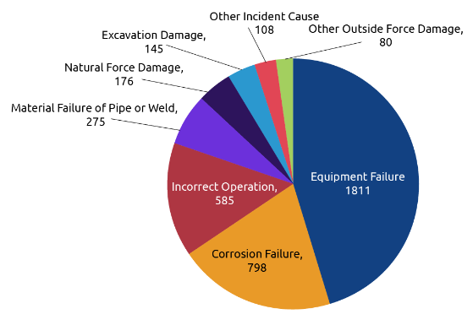

Fig. 9. Cause of Pipeline Leaks: 2010-2019 [19]

Gas leaks may seem trivial, but they are an exceptional contributor to climate change while simultaneously endangering human health and surrounding infrastructure. First and foremost, the main concern of gas leaks in relation to climate change is the release of natural gases that are classified as greenhouse gases. According to Boston University researcher, Dr. Philips, “detecting and reducing pipeline leaks of [methane] and other hydrocarbons in natural gas are critical for reducing greenhouse gas emissions, improving air quality” [20]. Considering this statement with Aliso Canyon, a natural gas storage facility in California, a substantial amount of natural gas is being released into the atmosphere. Shown in figure 10, the estimated leak of the storage was about 58,000 +/- 12,000 kilograms of methane per hour in lane November 2015. By January 22, 2016, the facility has leaked a total of about 5 billion cubic feet of natural gas. Compared to carbon dioxide emissions, this number pales in comparison; however, studies have shown that methane “has a global warming potential (GWP) estimated at 28-36 times greater that carbon dioxide (CO2) over 100 years” [21]. Thus, the release of natural gases is more impactful on climate change than carbon dioxide.

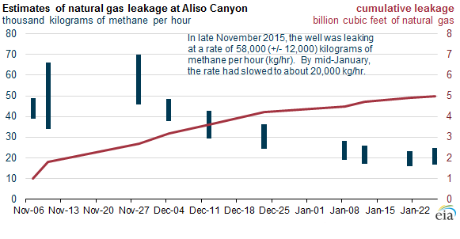

Fig. 10. Estimated Gas Leak at Aliso Canyon [21]

Speaking of the other drawbacks of gas leaks, they can pose a significant threat to health depending on the duration and amount a person is exposed to. Reported on the US Library of Medicine, the inhalation of natural gases can cause “headaches and dizziness, fatigue, nausea, irregular breathing. Exposure to high levels of natural gas can cause: death by suffocation, loss of consciousness, nausea, severe headaches, fatigue, memory problems, and lack of coordination” [22]. Health concerns involving the inhalation of natural gases are not the only dangers; there is an extreme risk of explosions occurring that may result in death and damage to infrastructure. For instance, “incidents involving transmission and distribution pipelines for natural gas in the U.S. cause an average of 17 fatalities, 68 injuries, and $133 M in property damage each year” [20]. An example of one such scenario would be the event that took place “in December 2019, a crack in a 6-inch natural gas pipe caused an explosion that killed two people in Philadelphia, PA and destroyed a good portion of one city block” [23]. Summing up the facts and considering the feedback we received, our team has come to the consensus that shifting our focus to gas leaks would make our design more relevant than had the societal problem remain wildfires.

1. DESIGN IDEA
2. *Spring Design Idea*

The design idea for the Spring 2020 semester was our initial prototype dedicated to addressing the impact of wildfires on climate change. During this time, our team had gone through many different design possibilities ranging from quadcopter drones to handheld devices. Ultimately, we had decided to design a rover type robot that would scout rural and suburban areas that had been overtaken by wildfires. This human controlled robot would go into buildings and dangerous areas to scout for victims and determine if it were safe for firefighters to proceed.

1. *Hardware*

For the hardware aspect of our design we decided to base our rover around the Raspberry Pi 4, a small single-board computer. This computer contains a 64-bit quad core processor operating at 1.5 GHz with features such as 2.4 GHz and 5.0 GHz IEEE 802.11 ac wireless and Bluetooth 5.0.

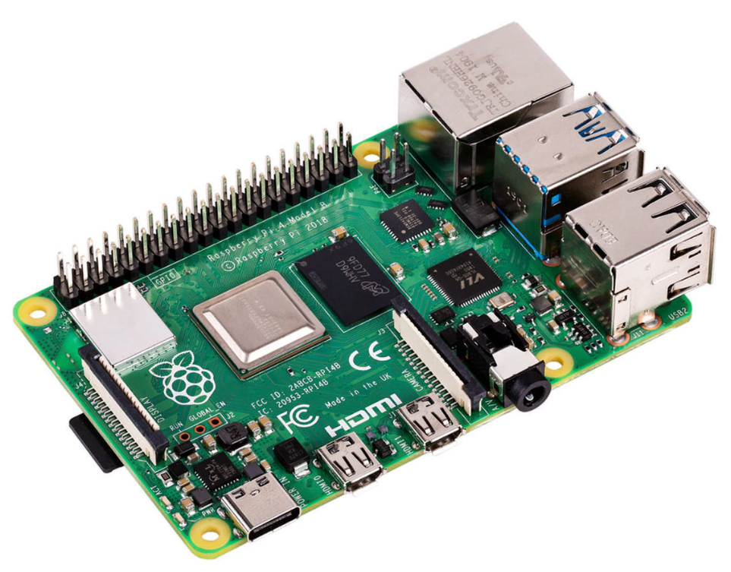

Fig. 11. Raspberry Pi 4 Model B [24]

Connected to the to the Raspberry Pi will be a multitude of electronic devices such as the Arduino Nano. The Nano will be used as the platform for our sensors as the documentation that we pulled for each sensor indicated that their usage was for Arduino.

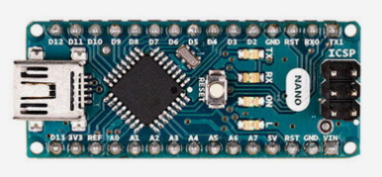

Fig. 12. Arduino Nano [25]

One of the three sensors that will be connected to the Arduino Nano is the DHT11 temperature-humidity sensor that is capable of measuring temperatures up to 50°C and humidity from the 20-80% range. Although the sensor’s maximum possible temperature reading is far below that of fire’s, the design is only intended to serve as a proof of concept.

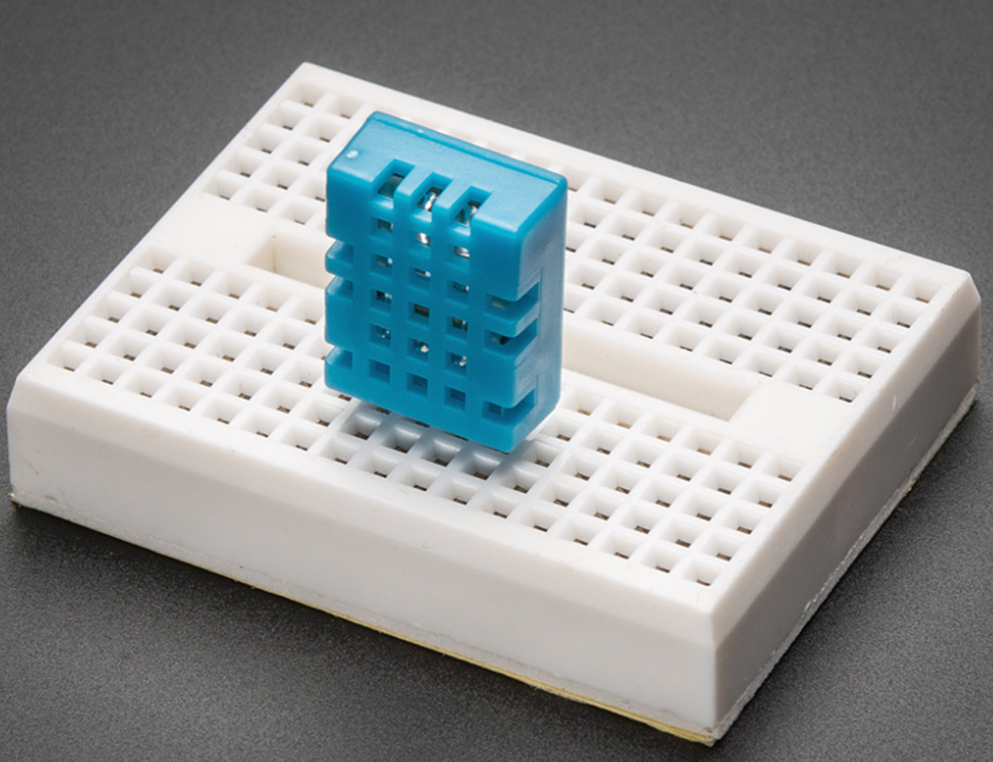

Fig. 13. DHT11 Temperature-Humidity Sensor [26]

Other such sensors that will be include for a wildfire setting are the MQ2 Gas and smoke sensor and the MQ-7 carbon monoxide (CO) sensor. Through research we discovered that measuring the particulates in the air is critical as toxic and combustible gas pose a significant threat as they are unperceivable by the naked eye. These three sensors will represent the semi-autonomous portion of our design since we intended for them to constantly gather data from the surround area.

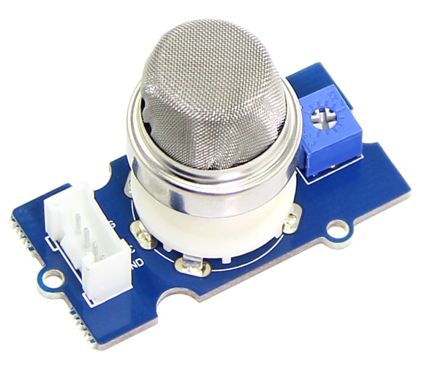

Fig. 14. MQ2 Combustible Gas and Smoke Sensor [27]

In terms of detailed specifications, the MQ2 sensor can measure a variety of combustible gases such as hydrogen (H2), liquified petroleum gas (LPG), and methane. Additionally, the sensor features a potentiometer that can adjust the sensitivity of the sensor.

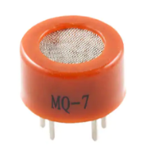

Fig. 15. MQ-7 Carbon Monoxide Sensor [28]

Another important feature connected to the Raspberry Pi is the OV5647 camera that will be connected through the dedicated camera module port.

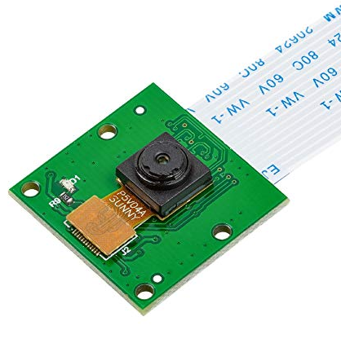

Fig. 16. OV5647 Camera [29]

The OV5647 features pictures up to 1080p and video up to 720p at 30 frames per second (fps) respectively. As for lens’s viewable distance, it has a field of view of 2.0 x 1.33 m at 2 m. The camera will provide operators visual feedback so that they can determine where they are moving. As for panning and tilting the camera, the horizontal movement of the camera will be dictated by turning the rover and the vertical movement will be performed by the SG90 servo shown in figure 17. Since some external casing will be required to mount the camera to the servo, we have ensured to have chosen one with suitable torque (2.5 kg/cm).

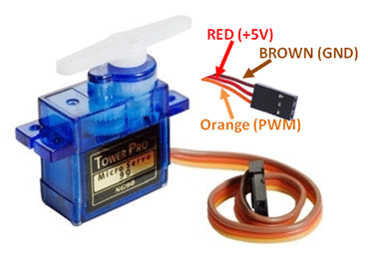

Fig. 17. SG90 Servo [30]

Regarding the chassis and movement of our rover, we are using an unbranded 232x193x73mm metal tank chassis purchased from eBay. For the integration of all our components, the final prototype will have been connected to the chassis to serve as the remote unit in our design idea.

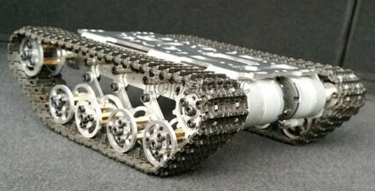

Fig. 18. Tank Chassis [31]

The chassis will be linked with 9 volts DC motors that will be connected to an H-Bridge to provide cardinal directional movement. While the forward and backward movements will have both motors running in the same direction, the left and right movements will involve each motor running in opposite directions. This will allow the rover to turn while remaining in the same position.

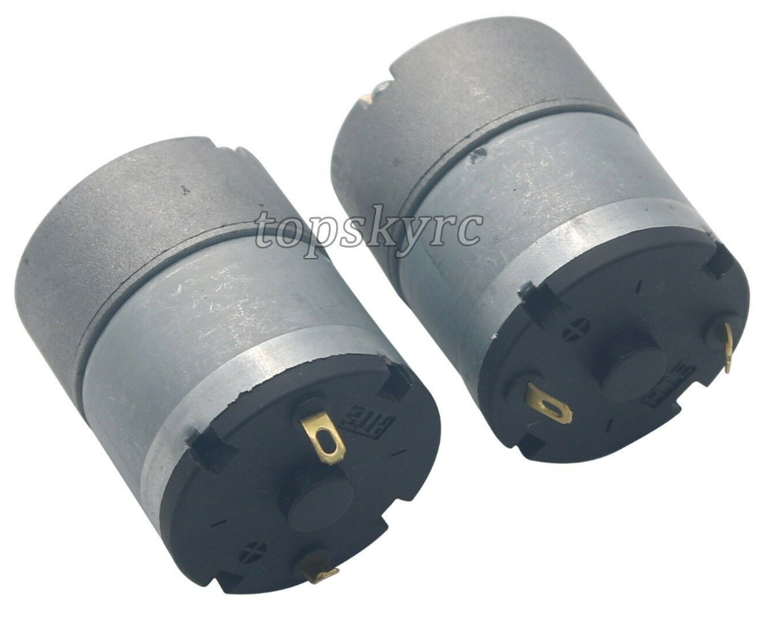

Fig. 19. 9 Volts DC Motors [31]

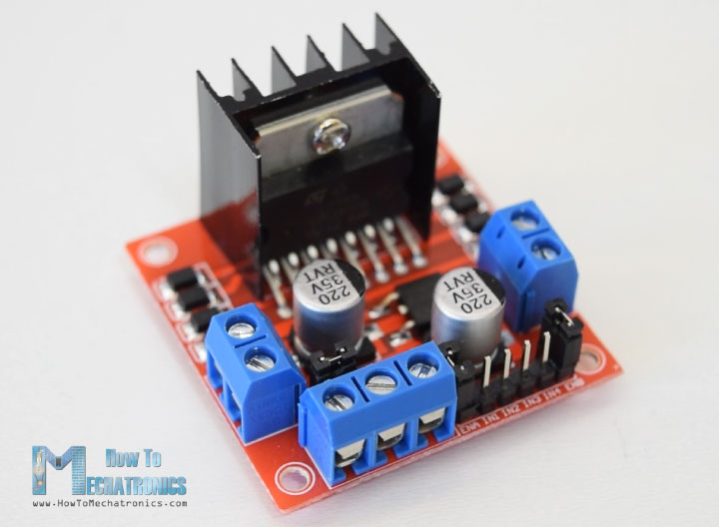

Fig. 20. L298N H-Bridge [32]

The final component of the rover aspect of our design are the batteries used to power the electronics. Due to size, space, and price limitations we decided to use two separate power sources: two 18650 2,600mAh rechargeable lithium ion batteries and a 10,000mAh RAVPower Rechargeable power bank.

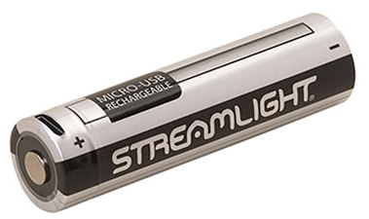

Fig. 21. 18650 Rechargeable Lithium Ion Battery [33]

Power distribution wise, the 18650 batteries are used to power the H-Bridge and the two DC motors whereas the RAVPower portable power bank is used to power the Arduino Nano, Raspberry Pi, SG90 Servo, and OV5647 camera.

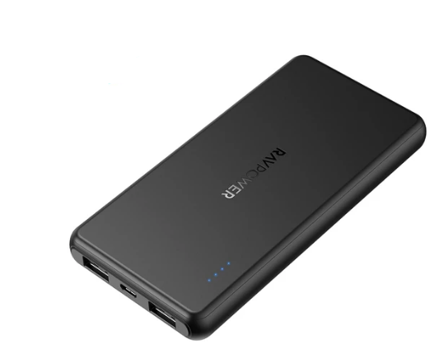

Fig. 22. RAVPower Portable Power Bank [34]

Regarding the actual usage of our device, the operator will require two separate pieces of equipment: a Bluetooth controller and a laptop or mobile device that supports a web browser. In the case of the Bluetooth controller, the one that our team opted to use was the SteelSeries Stratus XL shown in figure 23.

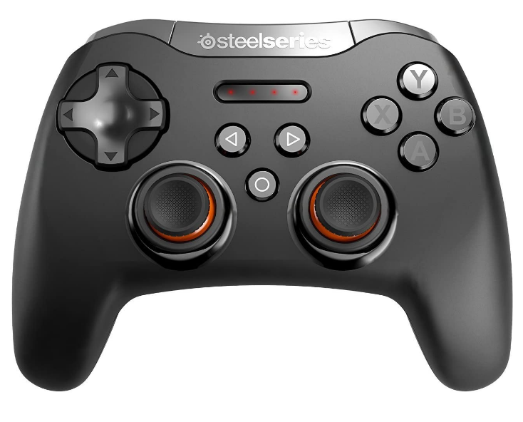

Fig. 23. SteelSeries Stratus XL Bluetooth Controller [35]

The mechanism in which the operator will remotely control the rover consists of connecting the controller to the Raspberry Pi via Bluetooth where a python script will then capture the inputs for the movement. The laptop or mobile device will then act as the Graphical User Interface (GUI) which will then display visuals from the camera and sensor data.

1. *Software*

Discussed briefly in the hardware section, the software component of our design will encompass two main parts: the web server located on the Raspberry Pi and the GUI that is displayed on the external device.

Beginning with the web server, it is built using the Python web framework called Flask. The server will be executed on the Raspberry Pi and the external device (laptop/mobile device) will connect via IP address which will then return the GUI as seen in figure 24. Additionally, the web server will act as the intermediary to pass data to the external device as well as accept any data through a HTTP protocol.

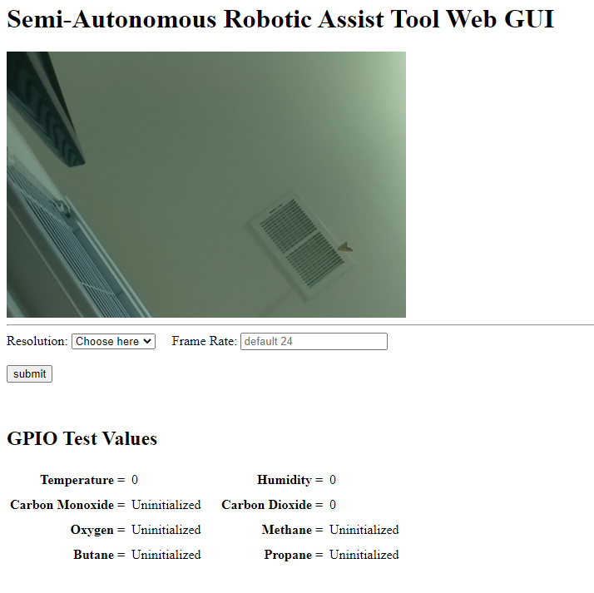

Fig. 24. Design GUI [36]

In terms of the GUI, the layout is simple to keep things clean and concise. The top half of the GUI will contain the video feed from the OV5647 camera while the bottom half will have the sensor data in near real-time. As for user control, they will have the ability to change the resolution and framerate of the camera to improve performance if there is poor signal or high network traffic.

1. *Fall Design Idea*

During our Fall 2020 semester we shifted our societal problem focus from wildfire to gas leaks after presenting our Spring 2020 design idea to our advisors and professionals. Although we have changed our societal problem focus, our design idea remains largely the same as we determined that it would be time and cost efficient to rebrand rather than recreate our design. Despite rebranding, we have made several changes and additions to both the hardware and software aspects of design to better suit our purpose.

1. *Hardware*

Compared to the Spring 2020 semester we have made several changes to the hardware aspect of our design. Beginning with the sensors, we have removed the DHT11 and MQ-7 because of some oversights and to expand the functionality of our design. For the MQ-7 we realized that the MQ2 also reads carbon monoxide so it would be redundant to keep it. As for the DHT11 we replaced it with the upgraded version called the DHT22 that has an expanded humidity reading range from 20-80% to 0-100%. Additionally, the range of possible temperature readings has also been expanded from 0-50°C to -40-80°C.

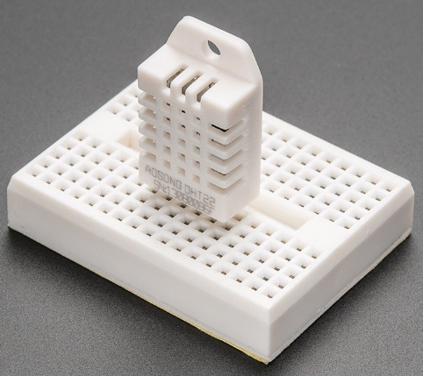

Fig. 25. DHT22 Temperature and Humidity Sensor [37]

In the scope of gas leaks, we have also decided to add the ME2-O2 oxygen sensor and the MQ135 air quality sensor. Since the previous focus was on wildfires and our design from last semester was an early prototype, we figured it would be beneficial to expand the functionality of our design so it was not just limited to gas leaks, but to other harmful gases as well.

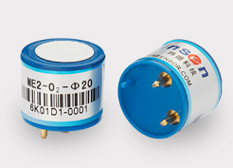

Fig. 26. ME2-O2 Oxygen Sensor [38]

The ME2-O2 oxygen sensor is designed to measure the percentage of oxygen in the air with anything rating above a 19.5% as safe. When the oxygen percentage dips below the threshold then that indicates there is a lack of oxygen or that is some other gas present. This would be ideal in confined spaces as we figured the device would be used in industrial and commercial settings where pipes are typically above ground.

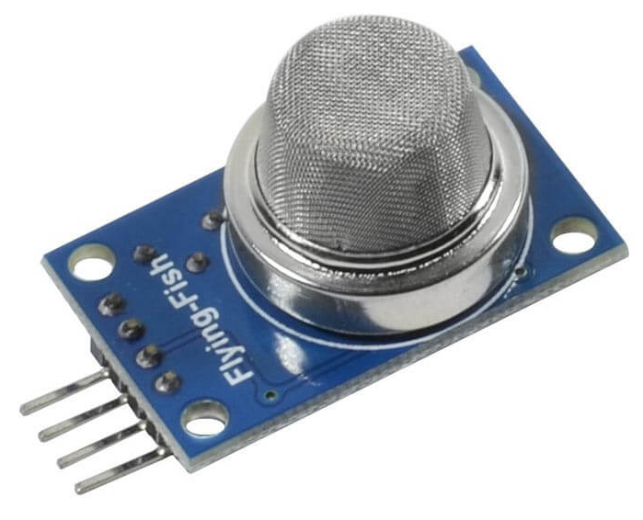

Fig. 27. MQ135 Air Quality Sensor [39]

The MQ135 is also in the same situation as the ME2-O2; the purpose of including is it expand the capabilities of our design instead of limiting it to natural gases and elements that may increase the chance of combustion. In terms of capabilities, the datasheet for the MQ135 indicates that it can measure ammonia, nitrogen oxide, alcohol, benzene, smoke, and carbon dioxide. In the case of our prototype we will only be utilizing its carbon dioxide sensing capabilities to showcase the ability to sense other gases besides natural and liquefied petroleum gas.

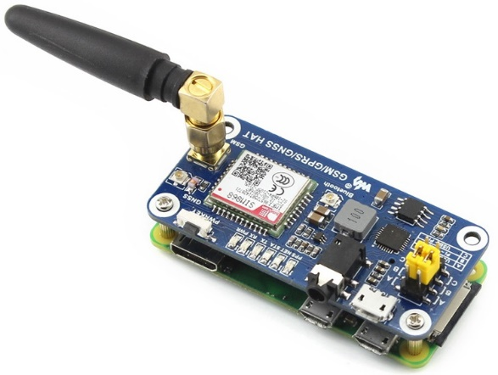

Fig. 28. SIM868 GPS Module [40]

Other hardware changes that were made to enhance our design was the addition of the SIM868 GPS module. Aside from the visual feedback from the camera, the addition of a GPS module would allow operators the ability to pinpoint the location of the rover without needing to have the starting position of the rover as a location indicator. This will allow the operator to focus solely on the operation of the rover without needing to memorize any other information. Although the visuals of the GPS aspect have not been fully implemented, the coordinates are being stored which will be explained further in the software section of the Fall 2020 semester.

Regarding the controls, we found through testing and research that the Bluetooth controller was consistently unresponsive, so we opted to remove it. The new method of controlling the rover is to use a laptop as the external device to display the GUI while also acting as the controller the keyboard button presses.

The last few changes of our design in relation to hardware were minor quality of life and cost saving changes. The most important change being the substitution of the Raspberry Pi 4 as we already had the Raspberry Pi 3 on hand, and we found that it worked well enough that it did not warrant the upgrade. Some other changes that were made was the inclusion of CPU cooler for the Raspberry Pi to ensure that there is no thermal throttling and switches to turn on the Raspberry Pi and H-Bridge.

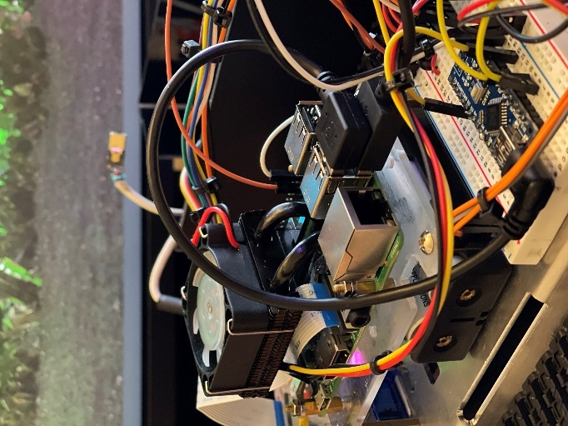

Fig. 29. Rover Interior [36]

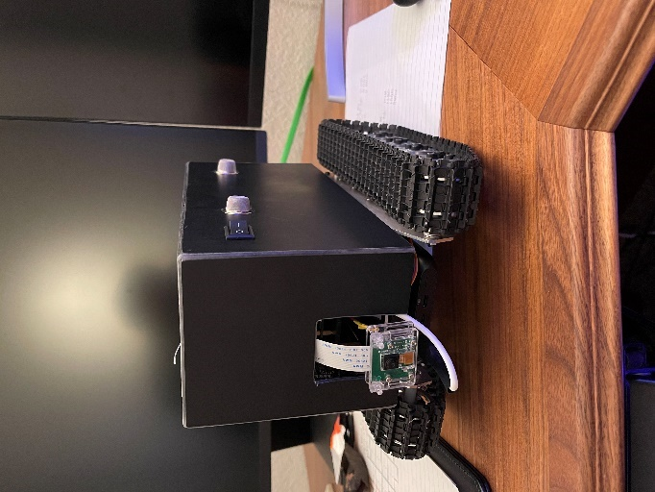

Fig. 30. Rover with Enclosure [36]

Figures 29 and 30 show the integrated design of our design with and without the enclosure.

1. *Software*

Comparing the Spring 2020 to Fall 2020, many of the software changes were done on the backend to improve performance and to add additional features that are not directly viewable.

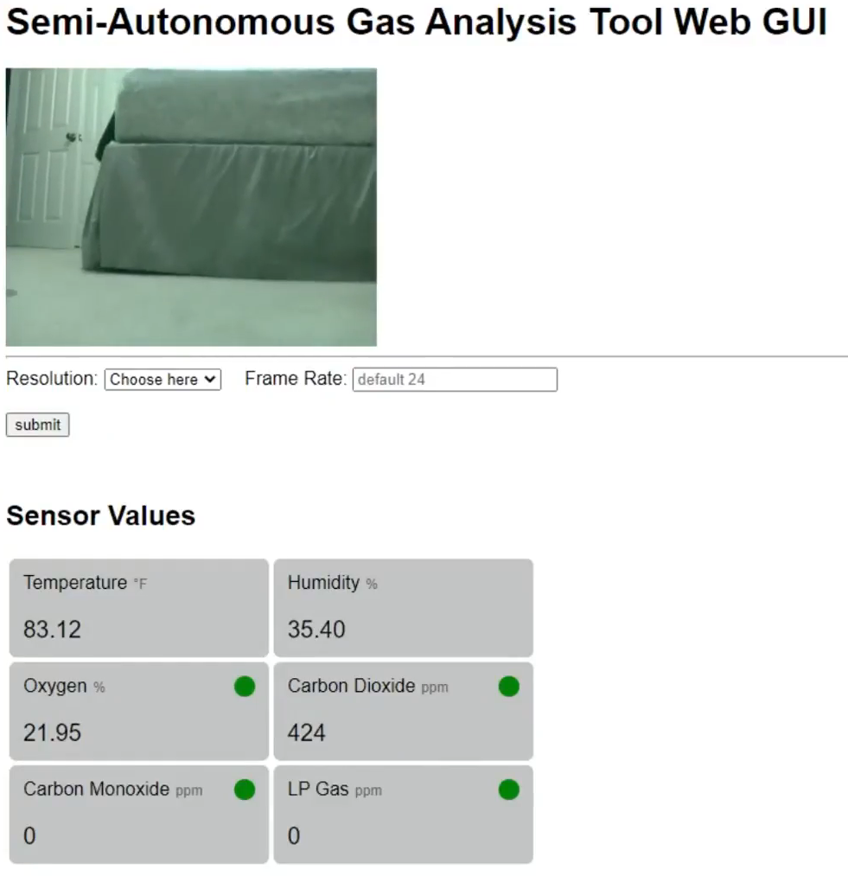

Fig. 31. Updated GUI for Fall 2020

Beginning with the viewable changes, the GUI received a visual update that separates each sensor value into their own section. Each section indicates the units the data is being measured in and if applicable, will contain a color-coded indicator to notify the operator if the gas values are safe (green), moderate (yellow), or dangerous (red). The values chosen for these thresholds were based on data from government websites and companies who manufacture gas sensors.

Regarding the backend changes, the data transfer method for updating gas values on the GUI was changed from HTTP protocol to WebSocket protocol. This new transfer protocol allowed for greater throughput while minimizing latency which is essential for near real-time operation. Another important addition to the backend was the implementation of data storage. The method of data storage that was implemented involved a snippet of Python code that would create a comma-separated values (CSV) file and then store our gas values. The reason behind choosing a CSV file was because of its widespread use and support from other spreadsheet programs. The stored data allows the operator and anyone else the ability to examine the gas levels that were measured and organize them via chart. Beyond these hardware and software changes, the work that the team has completed for the Fall 2020 semester is essentially our finished prototype.

1. FUNDING

Components required for the design of the rover were funded by the team. Figure [*insert number*] shows the material list and price of each component. The total spent on this prototype was $406.19 and it was split between each group member. The total that each group member contributed to the design of the rover was $101.55.

Table. 1. Component Costs [36]

|  |  |  |
| --- | --- | --- |
| **Item** | **Purchased By** | **Price** |
| Raspberry Pi 3 Model B | Team | $36.55 |
| Arduino Nano | Team | $22.25 |
| GPS Module (SIM868) | Team | $39.77 |
| Thermal and Humidity Sensor (DHT22) | Team | $7.69 |
| Carbon Dioxide Sensor (MQ-135) | Team | $6.33 |
| Hydrocarbon Sensor (MQ-2) | Team | $7.53 |
| Oxygen Sensor (ME2-O2) | Team | $59.02 |
| Rechargeable Batteries (18650) | Team | $44.07 |
| Camera (OV5647) | Team | $14.00 |
| LEDs (EK8437) | Team | $6.79 |
| Rechargeable Battery Bank (RAVPower) | Team | $10.76 |
| H-Bridge (LN298N) | Team | $8.69 |
| Servo (SG90) | Team | $10.55 |
| Tank Chassis | Team | $110.65 |
| Raspberry Pi Cooler (GeekPi) | Team | $21.54 |
| **TOTAL** |  | **$406.19** |
| **Group Member Contribution** |  | **$101.55** |

1. PROJECT MILESTONES

The project milestones represent key dates that helped keep our team focus while ensuring that the project would be delivered by the deadline.

Table 2. Spring 2020 Milestones [36]

|  |  |
| --- | --- |
| **Spring Semester 2020 Milestones** | **Date Completed** |
| Plan weekly meetings and dedicated work time considering COVID-19. Also determine societal problem | 2-05-2020 |
| Design Idea approval, research measurable metrics, and purchase material for prototype | 02-26-2020 |
| Produce a Risk Assessment Report | 03-25-2020 |
| Provide documentation of calibrations and work performed | 04-08-2020 |
| Project Technical Review Presentation & Perform the demonstration of all working parts required for the prototype individually | 05-08-2020 |

Table 3. Fall 2020 Milestones

|  |  |
| --- | --- |
| **Fall Semester 2020 Milestones** | **Date Completed** |
| Refine the project Idea and make necessary purchases | 09-09-2020 |
| Develop device test plan | 09-16-2020 |
| Integration of all sensors and power distribution on the Rover Unit for the initial demonstration | 10-14-2020 |
| Develop code for user interface and to handle incoming data | 11-04-2020 |
| Produce safe Test set up and document data from testing | 11-25-2020 |
| Present the finished product with full documentation completed. | 12-16-2020 |

1. WORK BREAKDOWN STRUCTURE
2. *Work Breakdown*

The work breakdown structure is a deliverable-oriented breakdown of a project into smaller components. It is utilized to provide a clear and understandable view of all aspects of a project and the different tasks that must be completed. Furthermore, it can exist in multiple formats such as a table, list, or diagram to serve as a visual aid to further clarify the task breakdown.

In respect to our design the project can be broken down into 8 different parts that represent a feature or task that must be completed. Shown in figure E-1 of the appendix, these parts include user control, user interface, camera, sensors, movement, communication, power management, and writing assignments. Theses parts can then be broken down yet again; so, in the case of the sensors part we have listed the four that we planned to include and then additional subtasks below each sensor indicating what implementation or testing that is required.

1. *Scheduling*

For our rover design during Spring 2020, each group member was delegated tasks to work on. We divided up tasks between the CpE and the EEE group members. The CpE group members are Andersen Huey and Justin Lieu. The EEE group members are Andrew Hall and Kelly Lopez. Ideally, our group wanted the CpEs to focus on working with the software side of the design and the EEE to focus on the hardware side of things but unfortunately due to the pandemic, tasks were changed for both the CpEs and the EEEs. Andersen Huey was assigned to work on the GUI for the rover along with getting a live feed from the camera to display on the GUI. Andrew Hall was assigned to work on the FIT0227 carbon monoxide sensor and calculating the power draw of each component. Justin Lieu was assigned to work on connecting the Bluetooth controller and controlling the motors for the rover and the DHT11 temperature and humidity sensor. Kelly Lopez was assigned to work on the MQ-2 hydrocarbon sensor and wiring the DC motors onto the chassis.

Continuing from the Spring semester, each group member was continuing to improve the components of their assigned tasks along with modifying what their designated tasks were. Andersen was assigned to improve the GUI for the rover along with improving live feed for the camera to display on the GUI and storing information gathered from the sensors. Andrew Hall was assigned to work on new sensors such as the MQ-135 carbon dioxide sensor, the ME2-O2 oxygen sensor, and calculating the power draw of each of the new components. Justin Lieu was assigned to improve on the rover controls, construction of the new rover chassis, and the DHT22 temperature and humidity sensor. Kelly Lopez was assigned to continue working on the MQ-2 Hydrocarbon Sensor and adding a SIM 868 GPS module.

1. RISK ASSESSMENT

With any project there is always a potential for accidents or unexpected events to occur that may impede project development. Thus, a risk assessment is created to gauge the possibility and impact of a risk and actions to take to minimize any disruptions.

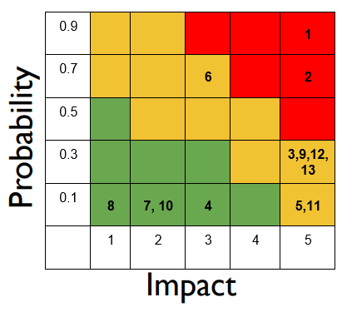

Fig. 32. Risk Matrix [36]

Shown in figure 32 is the risk matrix that was developed to account for several risks that our team may encounter during this project. Each number within the color grid represents a risk that is graded depending on the likelihood that it will occur and how much it will disrupt our project. Below is a list that corresponds with the risk matrix that we have developed

1. COVID-19
2. Bluetooth not connecting
3. Wi-Fi going down
4. Shorting out a motor
5. Frying a circuit board
6. Frying H-Bridges
7. Battery Failure
8. Fires
9. Defective Components
10. Parts disconnecting during usage
11. Parts breaking during shipment
12. Incompatibility with Parts
13. Exposure to high and low humidity environments

In response to these possible events that may stall our progress our team has created a detail plan that describes who would be responsible for resolving the issue, changes that need to be made, or any other problem solving related actions.

1. INTEGRATION PLAN

The integration plan details how we intended on combining all our separate portions of the project while simultaneously ensuring proper safety precautions were being taken. Listed below are the step by step procedures that were that we took to accomplish:

1. Justin will pass on the rover to Kelly by leaving the rover outside his house and Kelly will pick it up so that we may avoid contact with each other to prevent the spread of COVID-19
2. Justin and Andrew will work together virtually through discord to implement Justin’s DHT22 code into the sensor code.
3. Kelly will work with Andrew at his house, both will work in his garage at a distance from each other (6 feet). Both will be wearing facial masks and vinyl gloves while working together to implement the sensors on the chassis.
4. Both will test functionality and current draw of each component to test the run time of rover with all parts integrated. Furthermore, the wireless controller will be tested to determine the max distance the rover can be controlled.
5. After integrating and testing components, Kelly will pass the rover to Andersen by dropping it off on his driveway for contactless curbside pickup.
6. Andersen will integrate the camera with the servo and ensure that it is functioning as intended. Additionally, code will be written to display the GPS and sensor data being sent to the Raspberry Pi on the GUI.
7. Andersen will then pass the rover to Justin by dropping it off at his house on his driveway for contactless curbside pickup.
8. Justin will then implement the enclosure and quality of life (QOL) features such as a power switch and extension cables for charging the rover and associated devices.
9. CONCLUSION

In conclusion, climate change is a problem on a global scale that will impact both society and the environment if left unchecked. While climate change is a natural phenomenon, anthropogenic contributions such as fossil fuel combustion, deforestation, and other similar unsustainable actions are releasing unprecedented amounts of greenhouse gases that is causing global temperatures to rise. This temperature rise in turn causes increasing sea levels that threaten society through the enhancement of natural disasters such as hurricanes, floods, and tsunamis. Additionally, these rising sea levels threaten to put costal cities and regions underwater within the next century if temperatures increase continue at their current pace. Similarly, environments will be damaged irreparably as some organisms require a delicate balance of temperature for their biological processes. To combat this growing threat our team has chosen to address the contribution of gas leaks to climate change.

Through research, testing, and prototyping our team has created a designed called the Semi-Autonomous Gas Analysis Tool which will allow personnel to ability to remotely identify gas leaks in an industrial or commercial setting. Our design will be equipped with a multitude of sensors that will detect natural gases and other harmful gases as a bonus to increase its possible applications. Additionally, the remote feature that is comprised of a laptop capable of using a web browser provides a lightweight setup that is easy to setup and ensures the safety of the operator. In terms of the final prototype, the design is working as expected and would only require some minor modifications to the size and enclosure to give it better all terrain capabilities and a more professional look. Furthermore, the tests environment created to simulate industrial gas leaks yielded excellent results that proved the functionality of our design as they conformed to our measurable metrics.

REFERENCES

|  |  |
| --- | --- |
| [1] | L. J. Schmidt, "Satellite data confirm annual carbon dioxide minimum above 400 ppm," 30 Januray 2017. [Online]. Available: https://climate.nasa.gov/news/2535/satellite-data-confirm-annual-carbon-dioxide-minimum-above-400-ppm/. [Accessed 5 December 2020]. |
| [2] | US Geological Survey, "What is the difference between global warming and climate change?," [Online]. Available: https://www.usgs.gov/faqs/what-difference-between-global-warming-and-climate-change-1?qt-news_science_products=0#qt-news_science_products. [Accessed 05 December 2020]. |
| [3] | US Environmental Protection Agency, "Overview of Greenhouse Gases," 8 September 2020. [Online]. Available: https://www.epa.gov/ghgemissions/overview-greenhouse-gases. [Accessed 5 December 2020]. |
| [4] | National Oceanic and Atmospheric Administration, "Is sea level rising?," 5 November 2020. [Online]. Available: https://oceanservice.noaa.gov/facts/sealevel.html. [Accessed 5 December 2020]. |
| [5] | BBC News, "What is climate change? A really simple guide," 18 November 2020. [Online]. Available: https://www.bbc.com/news/science-environment-24021772. [Accessed 5 December 2020]. |
| [6] | C. Welch, "Sea turtles are being born mostly female due to warming—will they survive?," National Geographic, 4 April 2019. [Online]. Available: https://www.nationalgeographic.com/environment/2019/04/sea-turtle-sex-ratio-crisis-from-climate-change-has-hope/. [Accessed 5 December 2020]. |
| [7] | Center for Disease Control and Prevention, "Avoid Harmful Algal Blooms," 27 October 2020. [Online]. Available: https://www.cdc.gov/habs/be-aware-habs.html#:~:text=Harmful%20algal%20blooms%20can%20produce,sick%20and%20affect%20the%20environment.&text=Harmful%20algal%20blooms%20can%20make,nutrients%20in%20our%20waters%20increase.. [Accessed 5 December 2020]. |
| [8] | US Forest Service, "Fire Effects on the Environment," USDA, [Online]. Available: https://www.fs.usda.gov/pnw/page/fire-effects-environment#:~:text=Wildfire%20is%20a%20part%20of,emissions%20harmful%20to%20human%20health.&text=Fire%20severity%20can%20affect%20soil%20biota%2C%20reducing%20seedling%20performance. [Accessed 6 December 2020]. |
| [9] | K. Wells, "Steps to Reduce the Risk of Wildfires in California," The Wall Street Journal, 19 November 2019. [Online]. Available: https://www.wsj.com/articles/steps-to-reduce-the-risk-of-wildfires-in-california-11574209097. [Accessed 6 December 2020]. |
| [10] | C. Lee, C. Schlemme, J. Murray and R. Unsworth, "The cost of climate change: Ecosystem services and wildland fires," *Ecological Economics,* vol. 116, pp. 261-269, 2015. |
| [11] | K. M. Keegan, M. R. Albert, J. R. McConnell and I. Baker, "Climate change and forest fires synergistically drive widespread melt events of the Greenland Ice Sheet," *Proceedings of the National Academy of Sciences of the United States of America,* vol. 111, no. 22, pp. 7964-7., 2014. |
| [12] | K. Pierre-Louis and N. Popovich, "Climate Change Is Fueling Wildfires Nationwide, New Report Warns," The New York Times, 27 November 2018. [Online]. Available: https://www.nytimes.com/interactive/2018/11/27/climate/wildfire-global-warming.html. [Accessed 6 December 2020]. |
| [13] | US Department of the Interior, "New Analysis Shows 2018 California Wildfires Emitted as Much Carbon Dioxide as an Entire Year's Worth of Electricity," 11 November 2018. [Online]. Available: https://www.doi.gov/pressreleases/new-analysis-shows-2018-california-wildfires-emitted-much-carbon-dioxide-entire-years. [Accessed 6 December 2020]. |
| [14] | B. Berwyn, "How Wildfires Can Affect Climate Change (and Vice Versa)," InsideClimate News, 23 August 2018. [Online]. Available: https://insideclimatenews.org/news/23082018/extreme-wildfires-climate-change-global-warming-air-pollution-fire-management-black-carbon-co2. [Accessed 2020 December 2020]. |
| [15] | F. Reisen, S. M. Duran, M. Flannigan and C. Elliott, "Wildfire smoke and public health risk," *International Journal of Wildland Fire,* vol. 24, no. 8, pp. 1029-1044, 2015. |
| [16] | Verisk, "Verisk Wildfire Risk Analysis," [Online]. Available: https://www.verisk.com/insurance/campaigns/location-fireline-state-risk-report/. [Accessed 6 December 2020]. |
| [17] | National Centers for Environmental Information, "Billion-Dollar Weather and Climate Disasters: Summary Stats," National Oceanic and Atmospheric Administration, 2020. [Online]. Available: https://www.ncdc.noaa.gov/billions/summary-stats. [Accessed 6 December 2020]. |
| [18] | US Department of Energy, "Natural Gas Infrastructure," August 2015. [Online]. Available: https://www.energy.gov/sites/prod/files/2015/02/f19/DOE%20Report%20Natural%20Gas%20Infrastructure%20V_02-02.pdf. [Accessed 6 December 2020]. |
| [19] | M. Kelso, "FracTracker Alliance," 21 February 2020. [Online]. Available: https://www.fractracker.org/2020/02/pipelines-continue-to-catch-fire-and-explode/#tab-id-3-active. [Accessed 6 December 2020]. |
| [20] | N. G. Phillips, R. Ackley, E. R. Crosson and A. Down, "Mapping urban pipeline leaks: Methane leaks across Boston," *Envrionmental Pollution,* vol. 173, pp. 1-4, 2013. |
| [21] | US Energy Information Administration, "Natural gas leak at California storage site raises environmental and reliability concerns," 1 February 2016. [Online]. Available: https://www.eia.gov/todayinenergy/detail.php?id=24772. [Accessed 6 December 2020]. |
| [22] | ToxTown, "Natural Gas: Your Environment, Your Health," National Library of Medicine, 13 July 2018. [Online]. Available: https://toxtown.nlm.nih.gov/chemicals-and-contaminants/natural-gas. [Accessed 23 September 2020]. |
| [23] | J. B. A. Gomes, J. J. P. C. Rodrigues, R. A. L. Rabêlo and N. Kumar, "IoT-Enabled Gas Sensors: Technologies, Applications, and Opportunities," *Journal of Sensor and Actuator Networks,* vol. 8, no. 4, p. 57, 2019. |
| [24] | PiShop.us, "Raspberry Pi 4 Model B/8GB," [Online]. Available: https://www.pishop.us/product/raspberry-pi-4-model-b-8gb/?src=raspberrypi. [Accessed 7 December 2020]. |
| [25] | Arduino, "Arduino Nano," 2020. [Online]. Available: https://www.arduino.cc/en/pmwiki.php?n=Main/ArduinoBoardNano. [Accessed 8 December 2020]. |
| [26] | adafruit, "DHT11 basic temperature-humidity sensor + extras," [Online]. Available: https://www.adafruit.com/product/386. [Accessed 7 December 2020]. |
| [27] | Seeed, "Grove- Gas Sensor(MQ2)," [Online]. Available: https://wiki.seeedstudio.com/Grove-Gas_Sensor-MQ2/#specification. [Accessed 7 December 2020]. |
| [28] | Digi-Key Electronics, "SEN-09403," [Online]. Available: https://www.digikey.com/en/products/detail/sparkfun-electronics/SEN-09403/6163653. [Accessed 7 December 2020]. |
| [29] | ArduCam, "Arducam 5MP Mini Camera OV5647 Sensor 1080p 720p video for Raspberry Pi 4/3B+/3 Camera official Board," [Online]. Available: https://www.arducam.com/product/arducam-ov5647-standard-raspberry-pi-camera-b0033/. [Accessed 7 December 2020]. |
| [30] | Components 101, "Servo Motor SG-90," 18 September 2017. [Online]. Available: https://components101.com/servo-motor-basics-pinout-datasheet. [Accessed 7 December 2020]. |
| [31] | topskyrc, "Robot Tank Chassis Metal Independent System Tracked Vehicle Robotics DIY Kit US," [Online]. Available: https://www.ebay.com/itm/Robot-Tank-Chassis-Metal-Independent-System-Tracked-Vehicle-Robotics-DIY-Kit-US/182813066231?hash=item2a908203f7:g:FaUAAOSwt5tZ2KD7. [Accessed 7 December 2020]. |
| [32] | Dejan, "Arduino DC Motor Control Tutorial – L298N | PWM | H-Bridge," [Online]. Available: https://howtomechatronics.com/tutorials/arduino/arduino-dc-motor-control-tutorial-l298n-pwm-h-bridge/. [Accessed 7 December 2020]. |
| [33] | Streamlight, "Streamlight® Debuts 18650 USB Lithium Ion Battery with Integrated Charging Port," 13 February 2018. [Online]. Available: https://www.streamlight.com/community/newsletters-press/press-release/streamlight-debuts-18650-usb-lithium-ion-battery-with-integrated-charging-port. [Accessed 8 December 2020]. |
| [34] | RAVPower, "10000mAh Portable Charger 2-Port Power Bank," [Online]. Available: https://www.ravpower.com/products/rp-pb165-slim-10000mah-power-bank. [Accessed 8 December 2020]. |
| [35] | Amazon, "SteelSeries Stratus XL, Bluetooth Wireless Gaming Controller for Windows plus Android, Samsung Gear VR, HTC Vive, and Oculus (Renewed)," [Online]. Available: https://www.amazon.com/SteelSeries-Stratus-Bluetooth-Wireless-Controller/dp/B01M1GHE8R/ref=pd_lpo_147_t_1/135-0776409-6763814?_encoding=UTF8&pd_rd_i=B01M1GHE8R&pd_rd_r=93e38b84-41a0-49b2-9fcb-8ae90d761231&pd_rd_w=lZLdT&pd_rd_wg=GRBat&pf_rd_p=7b36d496-f366. [Accessed 8 December 2020]. |
| [36] | A. Hall, A. Huey, J. Lieu and K. Lopez, *Produced by one or more members of CSUS 2019-2020 Senior Design Team 10.* |
| [37] | adafruit, "DHT22 temperature-humidity sensor + extras," [Online]. Available: https://www.adafruit.com/product/385. [Accessed 8 December 2020]. |
| [38] | Winsen, "ME2-O2-Ф20 Oxygen Sensor," [Online]. Available: https://www.winsen-sensor.com/sensors/o2-sensor/me2-o2.html. [Accessed 8 December 2020]. |
| [39] | Cytron Marketplace, "MQ135 Air Quality Sensor Module," [Online]. Available: https://www.cytron.io/p-mq135-air-quality-sensor-module. [Accessed 8 December 2020]. |
| [40] | D. Akerman, "Making a Pi Zero GSM/GPS HAB Backup Tracker," 9 March 2018. [Online]. Available: https://www.daveakerman.com/?p=2340. [Accessed 8 December 2020]. |
| [41] | Occupational Safety & Health Administration, "Confined or Enclosed Spaces and Other Dangerous Atmospheres » Oxygen-Deficient or Oxygen-Enriched Atmospheres," US Department of Labor, [Online]. Available: https://www.osha.gov/SLTC/etools/shipyard/shiprepair/confinedspace/oxygendeficient.html. [Accessed 9 December 2020]. |
| [42] | Centers for Disease Control and Prevention, "Propane," May 1994. [Online]. Available: https://www.cdc.gov/niosh/idlh/74986.html. [Accessed 9 December 2020]. |
| [43] | National Comfort Institute, Inc, "Carbon Monoxide Levels & Risks," [Online]. Available: https://www.myhomecomfort.org/wp-content/uploads/2015/09/CO_Levels_Risk_Chart.pdf. [Accessed 9 December 2020]. |
| [44] | National Center for Biotechnology Information, US National Library of Medicine, 1984. [Online]. Available: https://www.ncbi.nlm.nih.gov/books/NBK208285/. [Accessed 9 December 2020]. |

GLOSSARY

Algal Bloom – Rapid growth of algae or cyanobacteria in water

Bluetooth – Wireless technology standard used for exchanging data over short distances through UHF radio waves

Climate Change – Change in global or regional climate patterns. Often used to refer to the change apparent from the mid-20th century to present day where increased levels of atmosphere carbon dioxide are observed

Carbon Dioxide (CO2) – A colorless and odorless gas produced by burning carbon and via respiration.

Comma-Separated Values (CSV) – A file type that uses commas to separate values

Fossil Fuels – Fuel formed by natural processes that is comprised of coal, petroleum, and natural gas

Gas Leak – Unintended leak of natural gas from a pipeline due to human error, corrosion, or equipment failure

Global Warming – A form of climate change involving the gradual increase of the overall temperature of Earth’s atmosphere that is generally attributed to the greenhouse effect

Greenhouse Effect – The process by which heat from the sun is trapped by the Earth’s atmosphere

Greenhouse Gasses – Gas that is present in the atmosphere and actively contributes to the greenhouse effect

H-Bridge – An electronic circuit capable of swapping the polarity of the voltage applied to the load

Hydrocarbon – Compound of hydrogen and carbon that are the primary components of petroleum gas

Hypertext Transfer Protocol (HTTP) – An application-layer protocol for transmitting hypermedia documents such as html

IEEE 802.11ac – Wireless networking standard providing high-throughput wireless local area network; also known as Wi-Fi 5

Ice Core – a long cylindrical block of ice typically removed from an ice sheet or glacier that is comprised of the incremental buildup of annual layers of snow

Liquefied Petroleum Gas (LPG) – Flammable mixture of hydrocarbon gas used as fuel for heating, cooking, and vehicles

Methane (CH4) – a colorless, odorless, and flammable gas that is the main constituent of natural gas

Python – A high-level and general-purpose programming language

Sea Level – The level of the sea’s surface; used as the baseline to measure elevation and depth

Water Vapor – The gaseous phase of water

WebSocket – Computer communication protocol

Wildfire – A large and destructive fire that spreads over woodland or brush; occurs often in rural areas

Work Breakdown Structure (WBS) – A deliverable-oriented breakdown of a project into smaller components

APPENDIX A. USER MANUAL

**Overview**

The Semi-Autonomous Gas Analysis Tool is a rover used detect the location of gas leaks in industrial settings. The rover will let users know certain types of dangerous gases that are released and whether it is safe to go into the area.

**Connecting to the Rover Remotely**

Step 1: Downloading MobaXterm

* Navigate to: <https://mobaxterm.mobatek.net/download.html>
* Download the terminal software.

Step 2: Connect Rover to Wi-Fi.

* Turn on rover by pressing on the power switches.
* Take off the enclosure on the Rover.
* Connect monitor and HDMI Cable to Raspberry Pi.
* Connect mouse and keyboard to Raspberry Pi.
* Navigate to the top right corner of the UI.
* Click on Wi-Fi Symbol shown in picture.



* Connect to any network e.g. Home Wi-Fi, Hotspot, etc.

Step 3: Obtaining IP address of network that Rover is connected to.

* Navigate to the top left corner of the UI.
* Click on the Terminal Symbol shown in picture.



* In the terminal, type: **ifconfig**
* Look for “inet” shown in the picture. This is the network IP that the rover will be on.

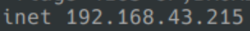

* Unplug HDMI Cable, Mouse, and Keyboard.
* Put the enclosure back onto the rover.

Step 4: Connecting the Rover to MobaXterm

* Open up MobaXterm on your computer.
* Navigate to the top left of the window.
* Click on Session. (Shown in picture)

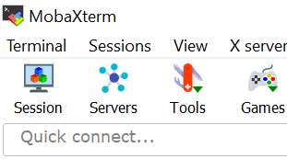

* Click on SSH. (Shown in picture)

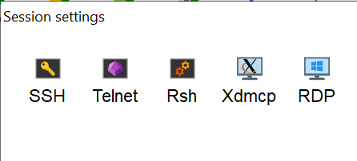

* Insert IP address obtained from Raspberry Pi (Shown in picture).

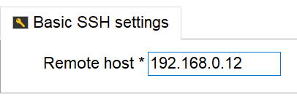

Step 5: Accessing Rover Remotely

* On the left side (Shown in picture), double click the IP that was just inputted.

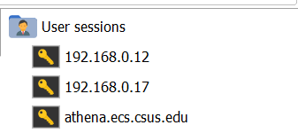

* Login for the rover is:
  + Username: pi
  + Password: raspberry

**How to Operate the Rover**

Step 1: Turning on and opening GUI

* Log into the rover through MobaXterm
* Type “**python main.py**”into the terminal to start the GUI.
* Go into a web browser of your choice
* Type in the IP of the Rover along with “:5000” into the search bar. Ex: 192.168.0.12:5000

Step 2: Turning on and using rover controls

* Log into the rover through MobaXterm.
* Type “**python main_control.py**” into the terminal to start controls.
* Wait a few seconds for a small window to appear.
* To control the rover, stay on the window that appears.
* Rover Controls:
  + Motors:
    - Up arrow: forward
    - Down arrow: reverse
    - Left arrow: left
    - Right arrow: right
  + Servo:
    - W key: up
    - S key: down
  + LED lights:
    - 1: On
    - 2: Off

**To run the GUI and rover controls concurrently:**

* Have the webpage open with the GUI while having the controller window opened on top of the webpage.

**\*Open two instances of the rover’s terminal to run the GUI and controls.**

**How to Charge the Rover (3 micro USB cables needed)**

Step 1: Charge Power Bank

* Plug a micro USB cable into charging port in power bank

Step 2: Charging Battery

* Take off enclosure
* Plug a micro USB (2 needed) cable into each of the batteries.

APPENDIX B. HARDWARE

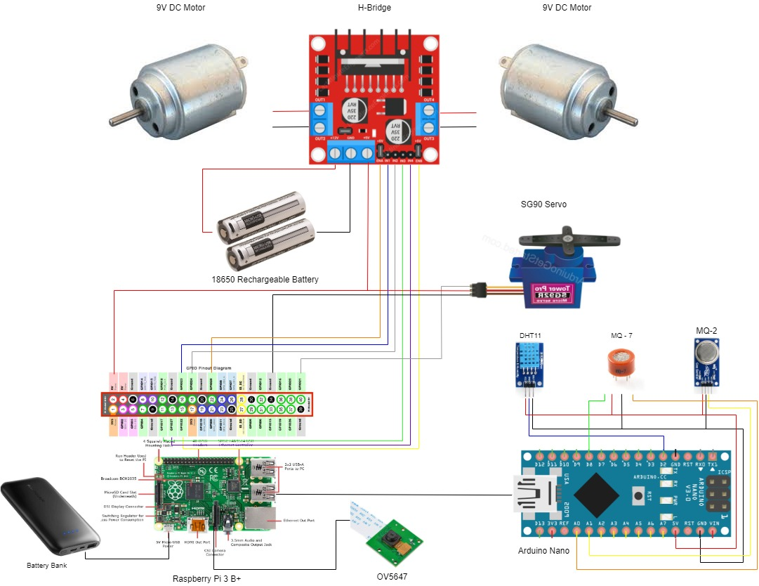

Fig. B-1. Spring 2020 Hardware Schematic [36]

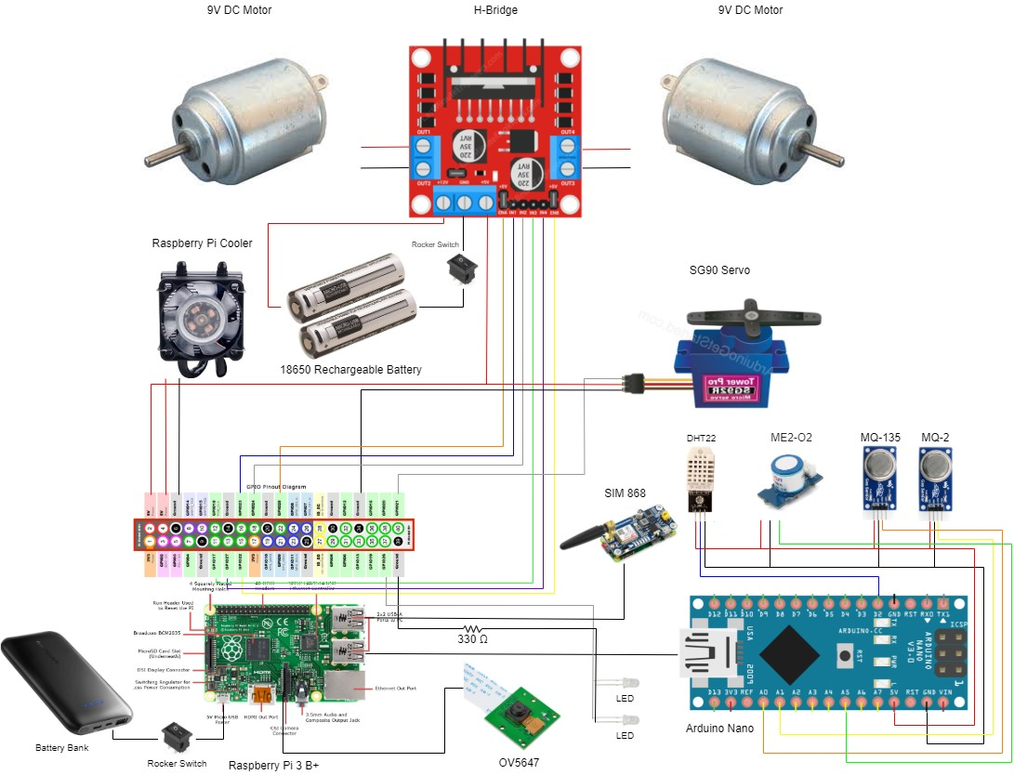

Fig. B-2. Fall 2020 Hardware Schematic [36]

Several changes with the rover as it transitioned from the spring prototype to the fall prototype. These changes were made to improve on the spring prototype and adapt to our changes to the societal problem.

Changes include:

* Removing MQ-7
* Adding MQ-135
* Adding ME2-O2
* Adding Raspberry Pi Cooler
* Adding Rocker Switches
* Adding LEDs
* Adding SIM868
* Replacing DHT11 with DHT22

The main control of our Semi-Autonomous Gas Analysis Rover is the Raspberry Pi 3 Model B. The Raspberry Pi controls the DC motors, servo, GPS module, LEDs, and the OV5647 camera which is all powered on through a battery bank. Our rover uses DC motors for movement, the servo is used to control the angle at which the camera will be facing, the GPS module is used to display the location of the rover, LEDs is used as lighting when the rover enters a dark area, and the OV5647 camera is used as a visual when operating the rover. Another power source on the rover is 18650 rechargeable batteries which is used to power on the H-Bridge for the DC motors. Rocker switches are used to power the H-Bridge and the Raspberry Pi on and off. An Arduino Nano is connected to the Raspberry Pi serially sending data captured from each sensor. The Arduino is used to pull information from the DHT22 sensor, the ME2-O2, the MQ-135, and the MQ-2. The DHT22 sensor is used to capture the humidity and temperature of the environment, the ME2-O2 sensor is used to capture the oxygen level in the surrounding area, the MQ-135 is used to capture carbon dioxide that is present in the air and the MQ-2 is used to capture carbon monoxide and LPG gases that also present in the air.

**Hardware Block Diagrams**

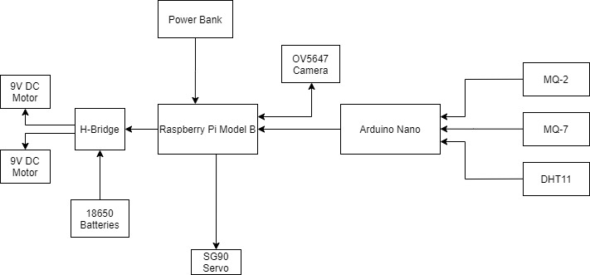

Fig. B-3. Spring 2020 Hardware Block Diagram [36]

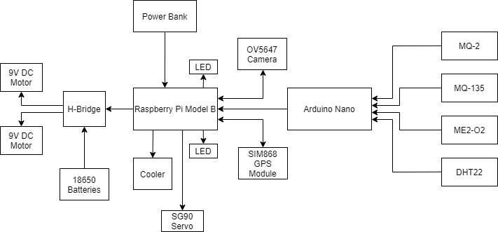

Fig. B-4. Fall 2020 Hardware Block Diagram [36]

The overall function of the rover remains the same throughout both the spring and the fall semester with slightly different hardware. Information read from the sensors from the Arduino Nano are sent serially to the Raspberry Pi. The Raspberry Pi controls most components on the rover which is powered on by a power bank. The Raspberry Pi sends signals to the H-Bridge, LEDs, a SG90 servo, a OV5647 camera, and a SIM868 GPS module. Both the camera and the GPS module gets sent a signal from the Raspberry Pi and returns information back to it. The signals that the H-Bridge gets from the Raspberry Pi is used to control the direction of the 9V DC motors.

**Hardware Test Plan**

A hardware test plan is a document that details and proves that the rover unit’s physical hardware meets the measurable metrics that have been outlined in our deliverables. The hardware test plan also provides clear documentation on the different conditions that the final product must endure as well as a list of its functional capabilities. The documented capabilities include the advertised battery life of the device, range of usage, or the ability to detect certain gases.

As part of our final documentation, our hardware test plan will describe how the design will overcome environmental factors in an industrial setting while also demonstrating how it will be utilized to detect gas leaks. Elaborating on the expected environmental factors in an industrial setting, the design is expected to overcome basic obstacles such as stairs, ramps, and other similar terrain. As for the functionality of our design, it is expected that it will be able to detect multiple types of gases, have user control, visual feedback in the form of video feed and data, and the ability to connect to it via Wi-Fi. Providing insight and a plan will inspire confidence that our laboratory prototype meets the measurable metrics that have been outlined in previous reports.

Measurable metrics such as temperature, humidity and other factors will be tested to ensure functionality of the final product. For our rover, we will be testing PPM of the gas sensors, temperature, humidity, distance of control/camera, movement through different terrain and GPS location.

The sensors that we implemented on the rover are the MQ2 Hydrocarbon Sensor which will be used to detect the presence of hydrocarbons gases (propane, methane, n-butane), smoke (suspended particles resulting from combustion) of hydrogen, and carbon monoxide.

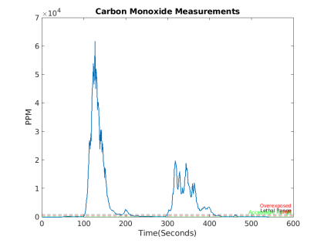

Fig. B-5 MATLAB Carbon Monoxide Plot [36]

Carbon Monoxide levels begin at hazardous levels at 35 ppm where OSHA states that exposure at these levels should not exceed 8 hours. At 200 ppm, humans will experience headaches and nausea. At 400 ppm, healthy adults will have headaches within 1-2 hours and be life threatening after 3 hours. 800 ppm, death is in 2 hours and 3000 ppm+ death in less than 30 minutes.

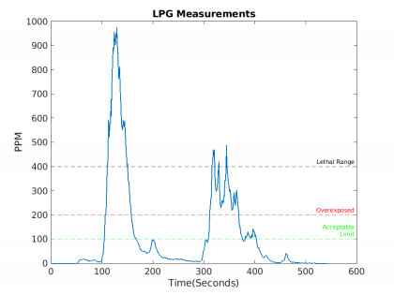

Fig. B-6 MATLAB LPG Plot [36]

Methane, it is a highly explosive gas that air containing more than 5.5% methane will combust if exposed to some source of ignition. In terms of ppm OSHA considers the lower explosive limit to be around 2100ppm and exposure limit to 1000ppm. Healthy adults will experience dizziness, confusion, excitation, asphyxia, and liquid: frostbite. For propane, the gas is dangerous to human life at around 20,000ppm but OSHA considers this gas to be dangerous at the lower explosive limit at about 2100ppm.

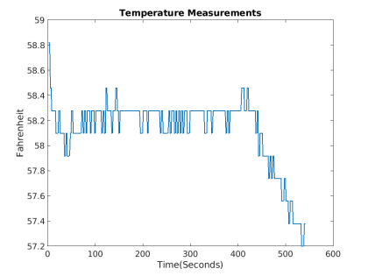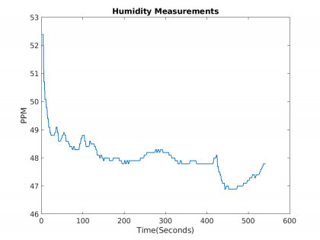

|  |  |
| --- | --- |
| Fig. B-7. MATLAB Temperature Plot [36] | Fig. B-8 MATLAB Humidity Plot [36] |

A DHT22 Temperature/Humidity Sensor is implemented on the robotic vehicle which is a low-cost digital temperature and humidity sensor. It uses a capacitive humidity sensor and a thermistor to measure the surrounding air and outputs a digital signal on the data pin.

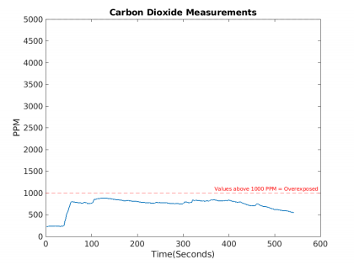

Fig. B-9 MATLAB Carbon Dioxide Plot [36]

We also implemented an MQ135 air quality sensor to detect CO2 levels. At about 1000 ppm of CO2 humans feel dizzy, while at 5000+ ppm is the threshold considered deadly.

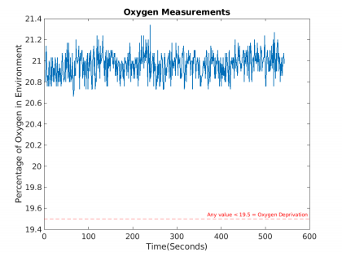

Fig. B-10 MATLAB Oxygen Plot [36]

Lastly, we installed an oxygen analyzer sensor that will track the percentage of oxygen present. Dangerous levels of oxygen are any percentages less than 19.5 percent. With all 4 sensors working simultaneously. We intend on utilizing our system by exposing trace amounts of harmful gases from a source to display capabilities of detecting potentially deadly amounts of gasses. To test the functionality of these sensors, we created an enclosed environment with very low concentration of these gases to read the ppm levels in the air to showcase the function of the sensor and sensitivity levels that these sensors present to capture accurate data of ppm concentration of gases focused on in this project.

APPENDIX C. SOFTWARE

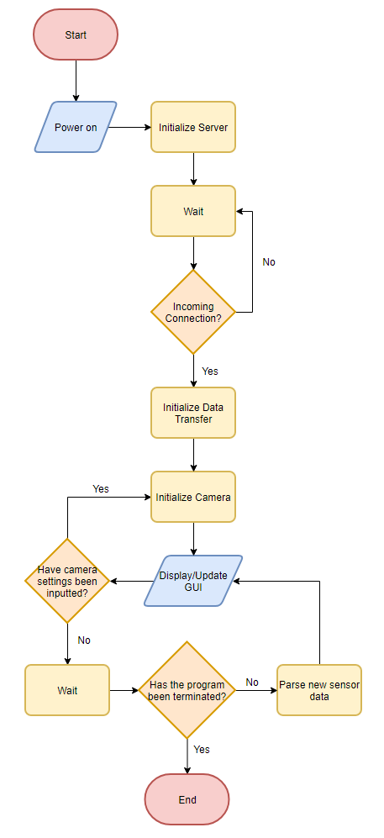

Fig. C-1. Web Server/GUI Flow Chart [36]

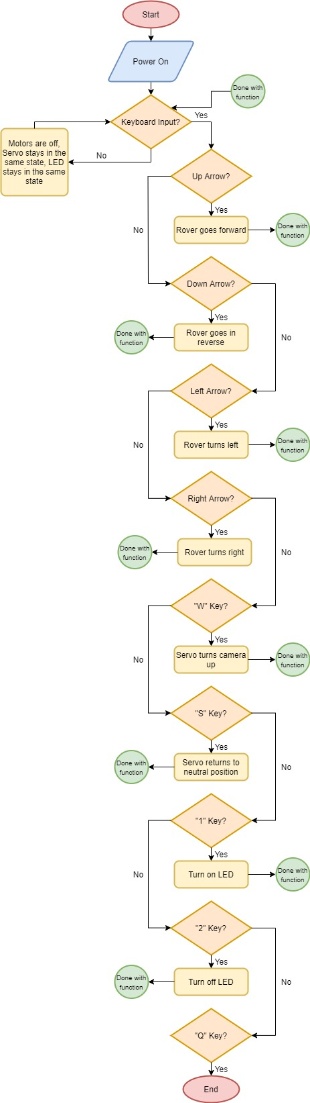

Fig. C-2. Rover Movement and Controls Flow Chart [36]

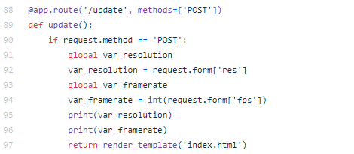

Fig. C-3 Code Snippet for Accepting Input From the GUI and Updating Resolution/Frame Rate [36]

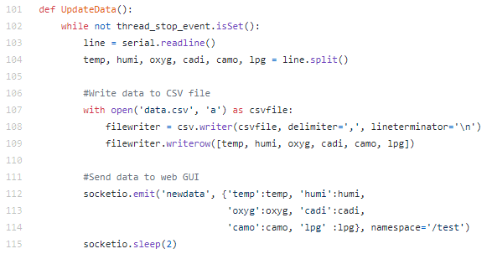

Fig. C-4. Code Snippet for Updating GUI Sensor Data and Writing to CSV file [36]

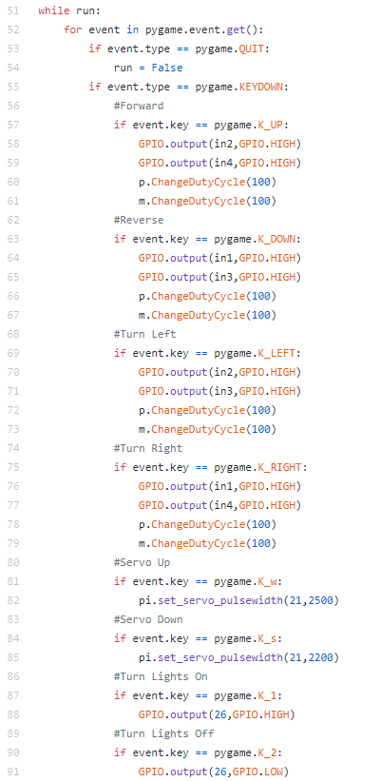

Fig. C-5. Code Snippet for Controlling the Rover via Keyboard [36]



Fig. C-6. Code Snippet to Read the LPG and CO Values from the MQ2 [36]

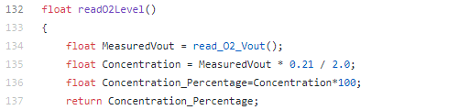

Fig. C-7. Code Snippet To Read Oxygen Percentage from the ME2-O2 Oxygen Sensor [36]

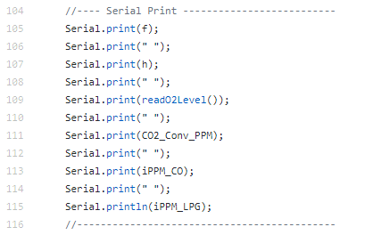

Fig. C-8. Code Snippet to Send Sensor Data to Raspberry Pi via USB [36]

**Software Test Plan**

A hardware test plan is a document that details and proves that the rover unit’s physical hardware meets the measurable metrics that have been outlined in our deliverables. The hardware test plan also provides clear documentation on the different conditions that the final product must endure as well as a list of its functional capabilities. The documented capabilities include the advertised battery life of the device, range of usage, or the ability to detect certain gases.

A software test plan is a document that details and proves that the rover unit’s software components meet the measurable metrics that have been outlined in our deliverables. The software test plan also provides clear documentation on the different conditions that the final product must be capable of withstanding.

The first part of our software test plan involves our user interface and the functionalities that it will have for the final prototype. Beginning with functionality, we have determined that the user interface must be able to show live video feed from the rover, real-time sensor data, and a color-coded indicator that will change based on the presence of the specified gas. To conduct most of these tests we will simply compare the data being displayed on the GUI with the data being outputted from the console and on the thresholds that we have set for the color-coded indicator. Additionally, the camera feed will be tested by moving the rover and ensuring that the delay on the live feed is within a reasonable margin.

Another aspect of software that can be tested are the controls which are responsible for moving the rover and performing other critical roles such as the tilting of the camera. For the actual tests, we can check for the responsiveness of the controls to confirm that there is no significant delay that may inhibit the movement. Additionally, we can test the rover for all terrain features to check if sufficient power is being supplied to the motors to give it enough torque to navigate through uneven or sloped areas.

The last aspect of software that can be tested is the data storage which will be responsible for storing all the data captured by the sensors and the coordinates from the GPS module. To test this functionality we will run the program and see if data is being displayed on the GUI; once complete, we will check the CSV file to see if the data had been stored.

APPENDIX D. MECHANICAL

Table D-1. Mechanical Specifications [36]

|  |  |
| --- | --- |
| Rover Specification | Value |
| Material | Thickened aluminum alloy plate |
| Size | 232mm*193mm*73mm (L*W*H) |
| Voltage | 9~12V (300 RPM/12V) |
| Weight | ~5lb |
| Enclosure Material | Black Acrylic (0.093 inches thick) |

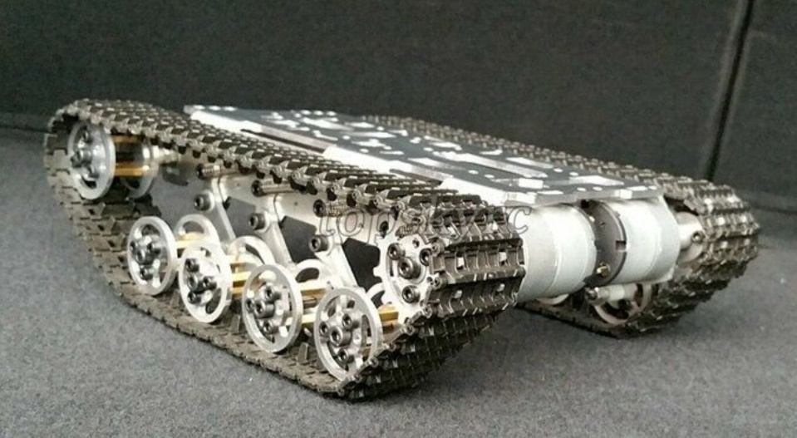

Fig. D-1. Tank Chassis [31]

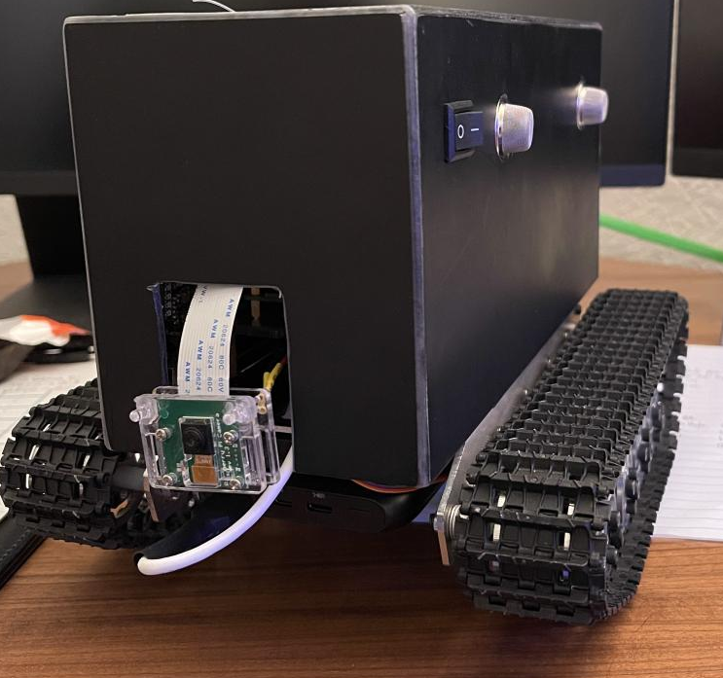

Fig. D-2. Rover with Enclosure [36]

APPENDIX E. WORK BREAKDOWN STRUCTURE

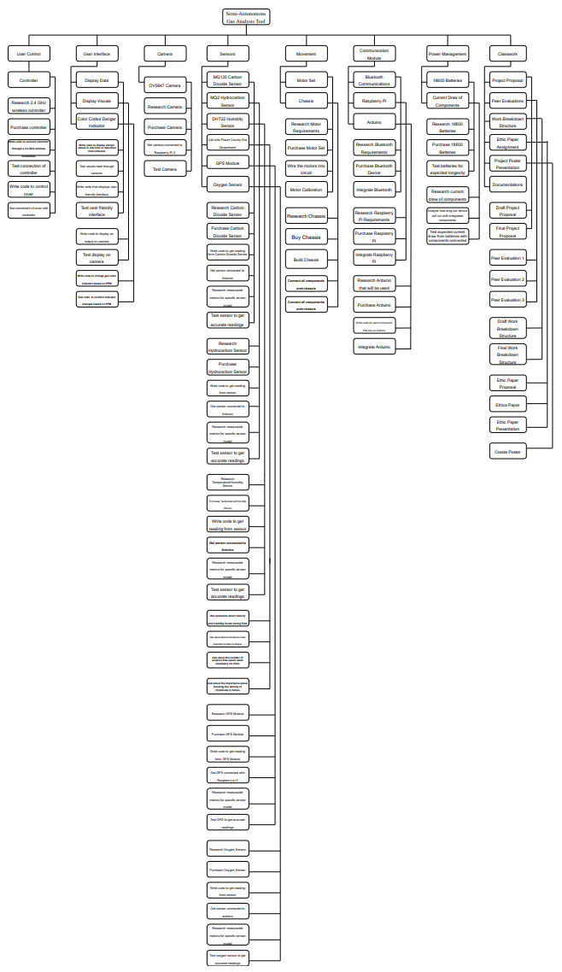

Fig. E-1. Fall 2020 Work Breakdown Structure [36]

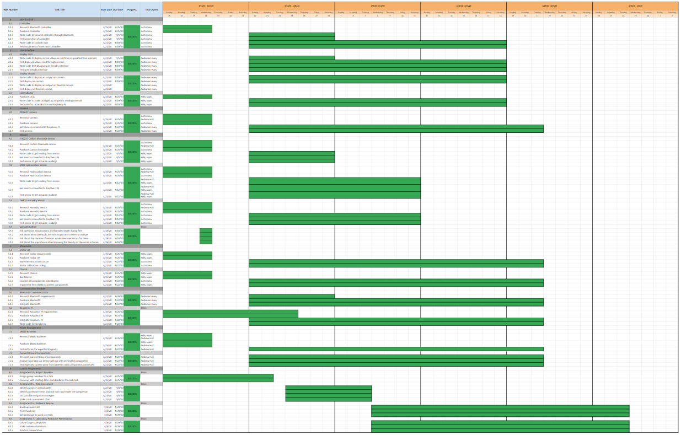

Fig. E-2. Spring 2020 Work Breakdown Structure Schedule [36]

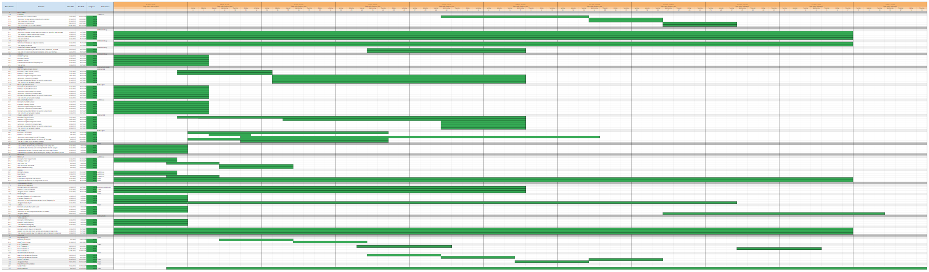

Fig. E-3. Fall 2020 Work Breakdown Structure Schedule [36]

APPENDIX F. RESUME

